Chapter 3

Solving Problems by Searching

In which we see how an agent can look ahead to find a sequence of actions that will eventually achieve its goal.

When the correct action to take is not immediately obvious, an agent may need to plan ahead: to consider a sequence of actions that form a path to a goal state. Such an agent is called a problem-solving agent, and the computational process it undertakes is called search.

Problem-solving agents use atomic representations, as described in Section 2.4.7-that is, states of the world are considered as wholes, with no internal structure visible to the problem-solving algorithms. Agents that use factored or structured representations of states are called planning agents and are discussed in Chapters 7 and 11.

We will cover several search algorithms. In this chapter, we consider only the simplest environments: episodic, single agent, fully observable, deterministic, static, discrete, and known. We distinguish between informed algorithms, in which the agent can estimate how far it is from the goal, and uninformed algorithms, where no such estimate is available. Chapter 4 relaxes the constraints on environments, and Chapter 5 considers multiple agents.

This chapter uses the concepts of asymptotic complexity that is, O(n) notation. Readers unfamiliar with these concepts should consult Appendix A.

3.1 Problem-Solving Agents
Imagine an agent enjoying a touring vacation in Romania. The agent wants to take in the sights, improve its Romanian, enjoy the nightlife, avoid hangovers, and so on. The decision problem is a complex one. Now, suppose the agent is currently in the city of Arad and has a nonrefundable ticket to fly out of Bucharest the following day. The agent observes street signs and sees that there are three roads leading out of Arad: one toward Sibiu, one to Timisoara, and one to Zerind. None of these are the goal, so unless the agent is familiar with the geography of Romania, it will not know which road to follow.^24
If the agent has no additional information—that is, if the environment is unknown—then the agent can do no better than to execute one of the actions at random. This sad situation is discussed in Chapter 4. In this chapter, we will assume our agents always have access to information about the world, such as the map in Figure 3.1. With that information, the agent can follow this four-phase problem-solving process:
- Goal formulation: The agent adopts the goal of reaching Bucharest. Goals organize behavior by limiting the objectives and hence the actions to be considered.
- Problem formulation: The agent devises a description of the states and actions necessary to reach the goal—an abstract model of the relevant part of the world. For our agent, one good model is to consider the actions of traveling from one city to an adjacent city, and therefore the only fact about the state of the world that will change due to an action is the current city.
- Search: Before taking any action in the real world, the agent simulates sequences of actions in its model, searching until it finds a sequence of actions that reaches the goal. Such a sequence is called a solution. The agent might have to simulate multiple sequences that do not reach the goal, but eventually it will find a solution such as going from Arad to Sibiu to Fagaras to Bucharest, or it will find that no solution is possible.
- Execution: The agent can now execute the actions in the solution, one at a time.
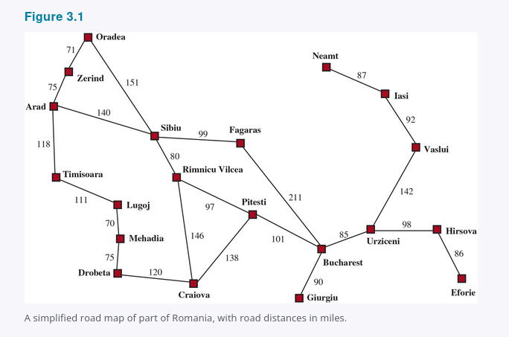

Here is the extracted text, with bold and italic formatting preserved as closely as possible:
It is an important property that in a fully observable, deterministic, known environment, the solution to any problem is a fixed sequence of actions: drive to Sibiu, then Fagaras, then Bucharest. If the model is correct, then once the agent has found a solution, it can ignore its percepts while it is executing the actions—closing its eyes, so to speak—because the solution is guaranteed to lead to the goal. Control theorists call this an open-loop system: ignoring the percepts breaks the loop between agent and environment. If there is a chance that the model is incorrect, or the environment is nondeterministic, then the agent would be safer using a closed-loop approach that monitors the percepts see Section 4.4.
In partially observable or nondeterministic environments, a solution would be a branching strategy that recommends different future actions depending on what percepts arrive. For example, the agent might plan to drive from Arad to Sibiu but might need a contingency plan in case it arrives in Zerind by accident or finds a sign saying “Drum Închis” Road Closed.

3.1.1 Search problems and solutions
A search problem can be defined formally as follows:
- A set of possible states that the environment can be in. We call this the state space.
- The initial state that the agent starts in. For example: Arad.
- A set of one or more goal states. Sometimes there is one goal state e.g., Bucharest, sometimes there is a small set of alternative goal states, and sometimes the goal is defined by a property that applies to many states potentially an infinite number. For example, in a vacuum-cleaner world, the goal might be to have no dirt in any location, regardless of any other facts about the state. We can account for all three of these possibilities by specifying an Is-Goal method for a problem. In this chapter we will sometimes say “the goal” for simplicity, but what we say also applies to “any one of the possible goal states.”
- The actions available to the agent. Given a state s, ACTIONS(s) returns a finite set of actions that can be executed in s. We say that each of these actions is applicable in s. An example:
ACTIONS(Arad) = {ToSibiu, ToTimisoara, ToZerind}.
- A transition model, which describes what each action does. RESULT(s, a) returns the state that results from doing action a in state s. For example,
RESULT(Arad, ToZerind) = Zerind.
- An action cost function, denoted by ACTION-COST(s, a, s′) when we are programming or c(s, a, s′) when we are doing math, that gives the numeric cost of applying action a in state s to reach state s′. A problem-solving agent should use a cost function that reflects its own performance measure; for example, for route-finding agents, the cost of an action might be the length in miles as seen in Figure 3.1, or it might be the time it takes to complete the action.
A sequence of actions forms a path, and a solution is a path from the initial state to a goal state. We assume that action costs are additive; that is, the total cost of a path is the sum of the individual action costs. An optimal solution has the lowest path cost among all solutions. In this chapter, we assume that all action costs will be positive, to avoid certain complications.
The state space can be represented as a graph in which the vertices are states and the directed edges between them are actions. The map of Romania shown in Figure 3.1 is such a graph, where each road indicates two actions, one in each direction.

3.1.2 Formulating problems
Our formulation of the problem of getting to Bucharest is a model—an abstract mathematical description—and not the real thing. Compare the simple atomic state description Arad to an actual cross-country trip, where the state of the world includes so many things: the traveling companions, the current radio program, the scenery out of the window, the proximity of law enforcement officers, the distance to the next rest stop, the condition of the road, the weather, the traffic, and so on. All these considerations are left out of our model because they are irrelevant to the problem of finding a route to Bucharest.
The process of removing detail from a representation is called abstraction. A good problem formulation has the right level of detail. If the actions were at the level of “move the right foot forward a centimeter” or “turn the steering wheel one degree left,” the agent would probably never find its way out of the parking lot, let alone to Bucharest.
Can we be more precise about the appropriate level of abstraction? Think of the abstract states and actions we have chosen as corresponding to large sets of detailed world states and detailed action sequences. Now consider a solution to the abstract problem: for example, the path from Arad to Sibiu to Rimnicu Vilcea to Pitesti to Bucharest. This abstract solution corresponds to a large number of more detailed paths. For example, we could drive with the radio on between Sibiu and Rimnicu Vilcea, and then switch it off for the rest of the trip.
The abstraction is valid if we can elaborate any abstract solution into a solution in the more detailed world; a sufficient condition is that for every detailed state that is “in Arad,” there is a detailed path to some state that is “in Sibiu,” and so on. The abstraction is useful if carrying out each of the actions in the solution is easier than the original problem; in our case, the action “drive from Arad to Sibiu” can be carried out without further search or planning by a driver with average skill. The choice of a good abstraction thus involves removing as much detail as possible while retaining validity and ensuring that the abstract actions are easy to carry out. Were it not for the ability to construct useful abstractions, intelligent agents would be completely swamped by the real world.

3.2 Example Problems
The problem-solving approach has been applied to a vast array of task environments. We list some of the best known here, distinguishing between standardized and real-world problems. A standardized problem is intended to illustrate or exercise various problem-solving methods. It can be given a concise, exact description and hence is suitable as a benchmark for researchers to compare the performance of algorithms. A real-world problem, such as robot navigation, is one whose solutions people actually use, and whose formulation is idiosyncratic, not standardized, because, for example, each robot has different sensors that produce different data.

3.2.1 Standardized problems
A grid world problem is a two-dimensional rectangular array of square cells in which agents can move from cell to cell. Typically the agent can move to any obstacle-free adjacent cell—horizontally or vertically and in some problems diagonally. Cells can contain objects, which the agent can pick up, push, or otherwise act upon; a wall or other impassible obstacle in a cell prevents an agent from moving into that cell. The vacuum world from Section 2.1 can be formulated as a grid world problem as follows:
- States: A state of the world says which objects are in which cells. For the vacuum world, the objects are the agent and any dirt. In the simple two-cell version, the agent can be in either of the two cells, and each call can either contain dirt or not, so there are 2 · 2 · 2 = 8 states see Figure 3.2. In general, a vacuum environment with n cells has n · 2^n states.

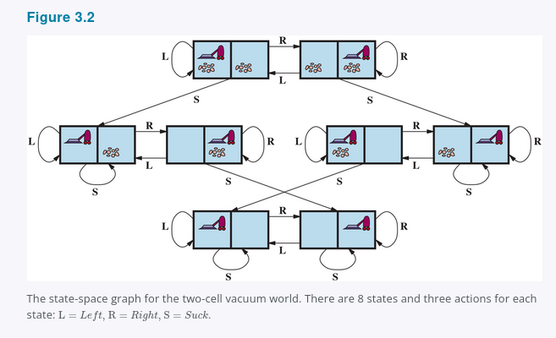

- Initial state: Any state can be designated as the initial state.
- Actions: In the two-cell world we defined three actions: Suck, move Left, and move Right. In a two-dimensional multi-cell world we need more movement actions. We could add Upward and Downward, giving us four absolute movement actions, or we could switch to egocentric actions, defined relative to the viewpoint of the agent—for example, Forward, Backward, TurnRight, and TurnLeft.
- Transition model: Suck removes any dirt from the agent’s cell; Forward moves the agent ahead one cell in the direction it is facing, unless it hits a wall, in which case the action has no effect. Backward moves the agent in the opposite direction, while TurnRight and TurnLeft change the direction it is facing by 90°.
- Goal states: The states in which every cell is clean.
- Action cost: Each action costs 1.
Another type of grid world is the sokoban puzzle, in which the agent’s goal is to push a number of boxes, scattered about the grid, to designated storage locations. There can be at most one box per cell. When an agent moves forward into a cell containing a box and there is an empty cell on the other side of the box, then both the box and the agent move forward. The agent can’t push a box into another box or a wall. For a world with n non-obstacle cells and b boxes, there are n × n!/(b!(n − b)!) states; for example on an 8 × 8 grid with a dozen boxes, there are over 200 trillion states.
In a sliding-tile puzzle, a number of tiles sometimes called blocks or pieces are arranged in a grid with one or more blank spaces so that some of the tiles can slide into the blank space. One variant is the Rush Hour puzzle, in which cars and trucks slide around a 6 × 6 grid in an attempt to free a car from the traffic jam. Perhaps the best-known variant is the 8-puzzle see Figure 3.3, which consists of a 3 × 3 grid with eight numbered tiles and one blank space, and the 15-puzzle on a 4 × 4 grid. The object is to reach a specified goal state, such as the one shown on the right of the figure. The standard formulation of the 8 puzzle is as follows:
- States: A state description specifies the location of each of the tiles.
- Initial state: Any state can be designated as the initial state. Note that a parity property partitions the state space—any given goal can be reached from exactly half of the possible initial states see Exercise 3.PART.
- Actions: While in the physical world it is a tile that slides, the simplest way of describing an action is to think of the blank space moving Left, Right, Up, or Down. If the blank is at an edge or corner then not all actions will be applicable.
- Transition model: Maps a state and action to a resulting state; for example, if we apply Left to the start state in Figure 3.3, the resulting state has the 5 and the blank switched.
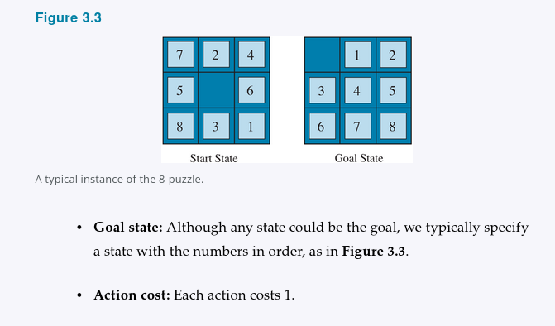

- Goal state: Although any state could be the goal, we typically specify a state with the numbers in order, as in Figure 3.3.
- Action cost: Each action costs 1.
Note that every problem formulation involves abstractions. The 8-puzzle actions are abstracted to their beginning and final states, ignoring the intermediate locations where the tile is sliding. We have abstracted away actions such as shaking the board when tiles get stuck and ruled out extracting the tiles with a knife and putting them back again. We are left with a description of the rules, avoiding all the details of physical manipulations.
Our final standardized problem was devised by Donald Knuth 1964 and illustrates how infinite state spaces can arise. Knuth conjectured that starting with the number 4, a sequence of square root, floor, and factorial operations can reach any desired positive integer. For example, we can reach 5 from 4 as follows:
floor(sqrt(sqrt(sqrt(sqrt(sqrt((4!)!)))))) = 5.
The problem definition is simple:
- States: Positive real numbers.
- Initial state: 4.
- Actions: Apply square root, floor, or factorial operation factorial for integers only.
- Transition model: As given by the mathematical definitions of the operations.
- Goal state: The desired positive integer.
- Action cost: Each action costs 1.
The state space for this problem is infinite: for any integer greater than 2 the factorial operator will always yield a larger integer. The problem is interesting because it explores very large numbers: the shortest path to 5 goes through (4!)! = 620,448,401,733,239,439,360,000. Infinite state spaces arise frequently in tasks involving the generation of mathematical expressions, circuits, proofs, programs, and other recursively defined objects.

3.2.2 Real-world problems
We have already seen how the route-finding problem is defined in terms of specified locations and transitions along edges between them. Route-finding algorithms are used in a variety of applications. Some, such as Web sites and in-car systems that provide driving directions, are relatively straightforward extensions of the Romania example. The main complications are varying costs due to traffic-dependent delays, and rerouting due to road closures. Others, such as routing video streams in computer networks, military operations planning, and airline travel-planning systems, involve much more complex specifications. Consider the airline travel problems that must be solved by a travel-planning Web site:
- States: Each state obviously includes a location e.g., an airport and the current time. Furthermore, because the cost of an action a flight segment may depend on previous segments, their fare bases, and their status as domestic or international, the state must record extra information about these “historical” aspects.
- Initial state: The user’s home airport.
- Actions: Take any flight from the current location, in any seat class, leaving after the current time, leaving enough time for within-airport transfer if needed.
- Transition model: The state resulting from taking a flight will have the flight’s destination as the new location and the flight’s arrival time as the new time.
- Goal state: A destination city. Sometimes the goal can be more complex, such as “arrive at the destination on a nonstop flight.”
- Action cost: A combination of monetary cost, waiting time, flight time, customs and immigration procedures, seat quality, time of day, type of airplane, frequent-flyer reward points, and so on.

Commercial travel advice systems use a problem formulation of this kind, with many additional complications to handle the airlines’ byzantine fare structures. Any seasoned traveler knows, however, that not all air travel goes according to plan. A really good system should include contingency plans—what happens if this flight is delayed and the connection is missed?
Touring problems describe a set of locations that must be visited, rather than a single goal destination. The traveling salesperson problem (TSP) is a touring problem in which every city on a map must be visited. The aim is to find a tour with cost < C or in the optimization version, to find a tour with the lowest cost possible. An enormous amount of effort has been expended to improve the capabilities of TSP algorithms. The algorithms can also be extended to handle fleets of vehicles. For example, a search and optimization algorithm for routing school buses in Boston saved $5 million, cut traffic and air pollution, and saved time for drivers and students Bertsimas et al., 2019. In addition to planning trips, search algorithms have been used for tasks such as planning the movements of automatic circuit-board drills and of stocking machines on shop floors.
A VLSI layout problem requires positioning millions of components and connections on a chip to minimize area, minimize circuit delays, minimize stray capacitances, and maximize manufacturing yield. The layout problem comes after the logical design phase and is usually split into two parts: cell layout and channel routing. In cell layout, the primitive components of the circuit are grouped into cells, each of which performs some recognized function. Each cell has a fixed footprint size and shape and requires a certain number of connections to each of the other cells. The aim is to place the cells on the chip so that they do not overlap and so that there is room for the connecting wires to be placed between the cells. Channel routing finds a specific route for each wire through the gaps between the cells. These search problems are extremely complex, but definitely worth solving.
Robot navigation is a generalization of the route-finding problem described earlier. Rather than following distinct paths such as the roads in Romania, a robot can roam around, in effect making its own paths. For a circular robot moving on a flat surface, the space is essentially two-dimensional. When the robot has arms and legs that must also be controlled, the search space becomes many-dimensional—one dimension for each joint angle. Advanced techniques are required just to make the essentially continuous search space finite see Chapter 26. In addition to the complexity of the problem, real robots must also deal with errors in their sensor readings and motor controls, with partial observability, and with other agents that might alter the environment.
Automatic assembly sequencing of complex objects such as electric motors by a robot has been standard industry practice since the 1970s. Algorithms first find a feasible assembly sequence and then work to optimize the process. Minimizing the amount of manual human labor on the assembly line can produce significant savings in time and cost. In assembly problems, the aim is to find an order in which to assemble the parts of some object. If the wrong order is chosen, there will be no way to add some part later in the sequence without undoing some of the work already done. Checking an action in the sequence for feasibility is a difficult geometrical search problem closely related to robot navigation. Thus, the generation of legal actions is the expensive part of assembly sequencing. Any practical algorithm must avoid exploring all but a tiny fraction of the state space. One important assembly problem is protein design, in which the goal is to find a sequence of amino acids that will fold into a three-dimensional protein with the right properties to cure some disease.

3.3 Search Algorithms
A search algorithm takes a search problem as input and returns a solution, or an indication of failure. In this chapter we consider algorithms that superimpose a search tree over the state-space graph, forming various paths from the initial state, trying to find a path that reaches a goal state. Each node in the search tree corresponds to a state in the state space and the edges in the search tree correspond to actions. The root of the tree corresponds to the initial state of the problem.
It is important to understand the distinction between the state space and the search tree. The state space describes the possibly infinite set of states in the world, and the actions that allow transitions from one state to another. The search tree describes paths between these states, reaching towards the goal. The search tree may have multiple paths to and thus multiple nodes for any given state, but each node in the tree has a unique path back to the root as in all trees.
Figure 3.4 shows the first few steps in finding a path from Arad to Bucharest. The root node of the search tree is at the initial state, Arad. We can expand the node, by considering the available Actions for that state, using the Result function to see where those actions lead to, and generating a new node called a child node or successor node for each of the resulting states. Each child node has Arad as its parent node.
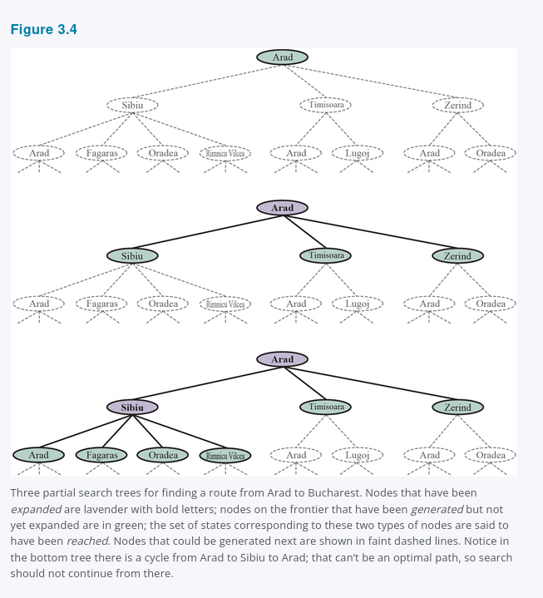

Now we must choose which of these three child nodes to consider next. This is the essence of search—following up one option now and putting the others aside for later. Suppose we choose to expand Sibiu first. Figure 3.4 (bottom) shows the result: a set of 6 unexpanded nodes (outlined in bold). We call this the frontier of the search tree. We say that any state that has had a node generated for it has been reached (whether or not that node has been expanded).28 Figure 3.5 shows the search tree superimposed on the state-space graph.
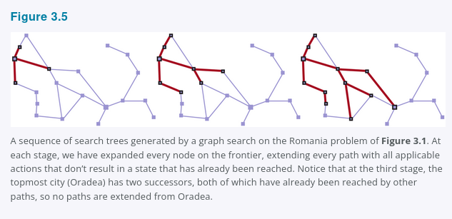

Note that the frontier separates two regions of the state-space graph: an interior region where every state has been expanded, and an exterior region of states that have not yet been reached. This property is illustrated in Figure 3.6.

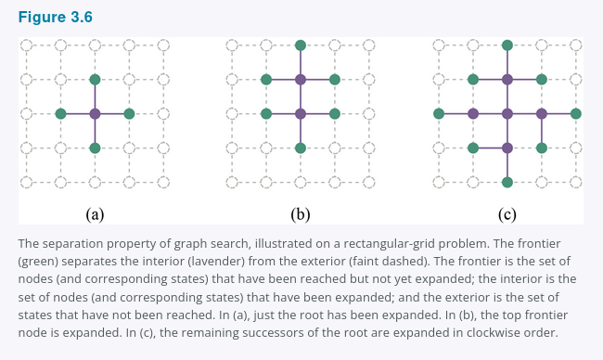

3.3.1 Best-first search
How do we decide which node from the frontier to expand next? A very general approach is called best-first search, in which we choose a node, n, with minimum value of some evaluation function, f(n). Figure 3.7 shows the algorithm. On each iteration we choose a node on the frontier with minimum f(n) value, return it if its state is a goal state, and otherwise apply Expand to generate child nodes. Each child node is added to the frontier if it has not been reached before, or is re-added if it is now being reached with a path that has a lower path cost than any previous path. The algorithm returns either an indication of failure, or a node that represents a path to a goal. By employing different f(n) functions, we get different specific algorithms, which this chapter will cover.

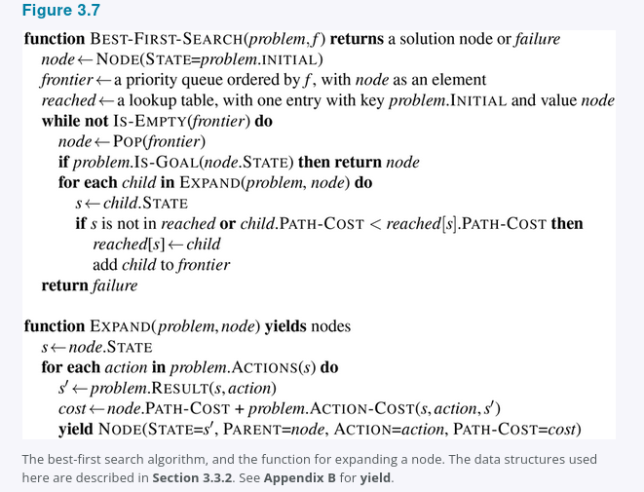

3.3.2 Search data structures
Search algorithms require a data structure to keep track of the search tree. A node in the tree is represented by a data structure with four components:
- node.STATE: the state to which the node corresponds;
- node.PARENT: the node in the tree that generated this node;
- node.ACTION: the action that was applied to the parent’s state to generate this node;
- node.PATH-COST: the total cost of the path from the initial state to this node. In mathematical formulas, we use g(node) as a synonym for PATH-COST.
Following the PARENT pointers back from a node allows us to recover the states and actions along the path to that node. Doing this from a goal node gives us the solution.
We need a data structure to store the frontier. The appropriate choice is a queue of some kind, because the operations on a frontier are:
- IS-EMPTY(frontier) returns true only if there are no nodes in the frontier.
- POP(frontier) removes the top node from the frontier and returns it.
- TOP(frontier) returns but does not remove the top node of the frontier.
- ADD(node, frontier) inserts node into its proper place in the queue.
Three kinds of queues are used in search algorithms:
- A priority queue first pops the node with the minimum cost according to some evaluation function, f. It is used in best-first search.
- A FIFO queue or first-in-first-out queue first pops the node that was added to the queue first; we shall see it is used in breadth-first search.
- A LIFO queue or last-in-first-out queue also known as a stack pops first the most recently added node; we shall see it is used in depth-first search.
The reached states can be stored as a lookup table e.g. a hash table where each key is a state and each value is the node for that state.

3.3.3 Redundant paths
The search tree shown in Figure 3.4 bottom includes a path from Arad to Sibiu and back to Arad again. We say that Arad is a repeated state in the search tree, generated in this case by a cycle also known as a loopy path. So even though the state space has only 20 states, the complete search tree is infinite because there is no limit to how often one can traverse a loop.
A cycle is a special case of a redundant path. For example, we can get to Sibiu via the path Arad-Sibiu 140 miles long or the path Arad-Zerind-Oradea-Sibiu 297 miles long. This second path is redundant, it’s just a worse way to get to the same state, and need not be considered in our quest for optimal paths.
Consider an agent in a 10 x 10 grid world, with the ability to move to any of 8 adjacent squares. If there are no obstacles, the agent can reach any of the 100 squares in 9 moves or fewer. But the number of paths of length 9 is almost 8^9 a bit less because of the edges of the grid, or more than 100 million. In other words, the average cell can be reached by over a million redundant paths of length 9, and if we eliminate redundant paths, we can complete a search roughly a million times faster. As the saying goes, algorithms that cannot remember the past are doomed to repeat it. There are three approaches to this issue.
First, we can remember all previously reached states as best-first search does, allowing us to detect all redundant paths, and keep only the best path to each state. This is appropriate for state spaces where there are many redundant paths, and is the preferred choice when the table of reached states will fit in memory.
Second, we can not worry about repeating the past. There are some problem formulations where it is rare or impossible for two paths to reach the same state. An example would be an assembly problem where each action adds a part to an evolving assemblage, and there is an ordering of parts so that it is possible to add A and then B, but not B and then A. For those problems, we could save memory space if we don’t track reached states and we don’t check for redundant paths. We call a search algorithm a graph search if it checks for redundant paths and a tree-like search if it does not check. The BEST-FIRST-SEARCH algorithm in Figure 3.7 is a graph search algorithm; if we remove all references to reached we get a tree-like search that uses less memory but will examine redundant paths to the same state, and thus will run slower.
Third, we can compromise and check for cycles, but not for redundant paths in general. Since each node has a chain of parent pointers, we can check for cycles with no need for additional memory by following up the chain of parents to see if the state at the end of the path has appeared earlier in the path. Some implementations follow this chain all the way up, and thus eliminate all cycles; other implementations follow only a few links e.g., to the parent, grandparent, and great-grandparent, and thus take only a constant amount of time, while eliminating all short cycles and relying on other mechanisms to deal with long cycles.

3.3.4 Measuring problem-solving performance
Before we get into the design of various search algorithms, we will consider the criteria used to choose among them. We can evaluate an algorithm’s performance in four ways:
- Completeness: Is the algorithm guaranteed to find a solution when there is one, and to correctly report failure when there is not?
- Cost optimality: Does it find a solution with the lowest path cost of all solutions?
- Time complexity: How long does it take to find a solution? This can be measured in seconds, or more abstractly by the number of states and actions considered.
- Space complexity: How much memory is needed to perform the search?
To understand completeness, consider a search problem with a single goal. That goal could be anywhere in the state space; therefore a complete algorithm must be capable of systematically exploring every state that is reachable from the initial state. In finite state spaces that is straightforward to achieve: as long as we keep track of paths and cut off ones that are cycles e.g. Arad to Sibiu to Arad, eventually we will reach every reachable state.
In infinite state spaces, more care is necessary. For example, an algorithm that repeatedly applied the “factorial” operator in Knuth’s “4” problem would follow an infinite path from 4 to 4! to (4!)!, and so on. Similarly, on an infinite grid with no obstacles, repeatedly moving forward in a straight line also follows an infinite path of new states. In both cases the algorithm never returns to a state it has reached before, but is incomplete because wide expanses of the state space are never reached.
To be complete, a search algorithm must be systematic in the way it explores an infinite state space, making sure that it can eventually reach any state that is connected to the initial state. For example, on the infinite grid, one kind of systematic search is a spiral path that covers all the cells that are s steps from the origin before moving out to cells that are s + 1 steps away. Unfortunately, in an infinite state space with no solution, a sound algorithm needs to keep searching forever; it can’t terminate because it can’t know if the next state will be a goal.
Time and space complexity are considered with respect to some measure of the problem difficulty. In theoretical computer science, the typical measure is the size of the state-space graph, |V| + |E|, where |V| is the number of vertices state nodes of the graph and |E| is the number of edges distinct state/action pairs. This is appropriate when the graph is an explicit data structure, such as the map of Romania. But in many AI problems, the graph is represented only implicitly by the initial state, actions, and transition model. For an implicit state space, complexity can be measured in terms of d, the depth or number of actions in an optimal solution; m, the maximum number of actions in any path; and b, the branching factor or number of successors of a node that need to be considered.

3.4 Uninformed Search Strategies
An uninformed search algorithm is given no clue about how close a state is to the goal(s). For example, consider our agent in Arad with the goal of reaching Bucharest. An uninformed agent with no knowledge of Romanian geography has no clue whether going to Zerind or Sibiu is a better first step. In contrast, an informed agent (Section 3.5) who knows the location of each city knows that Sibiu is much closer to Bucharest and thus more likely to be on the shortest path.

3.4.1 Breadth-first search
When all actions have the same cost, an appropriate strategy is breadth-first search, in which the root node is expanded first, then all the successors of the root node are expanded next, then their successors, and so on. This is a systematic search strategy that is therefore complete even on infinite state spaces. We could implement breadth-first search as a call to BEST-FIRST-SEARCH where the evaluation function f(n) is the depth of the node, that is, the number of actions it takes to reach the node.
However, we can get additional efficiency with a couple of tricks. A first-in-first-out queue will be faster than a priority queue, and will give us the correct order of nodes: new nodes which are always deeper than their parents go to the back of the queue, and old nodes, which are shallower than the new nodes, get expanded first. In addition, reached can be a set of states rather than a mapping from states to nodes, because once we’ve reached a state, we can never find a better path to the state. That also means we can do an early goal test, checking whether a node is a solution as soon as it is generated, rather than the late goal test that best-first search uses, waiting until a node is popped off the queue. Figure 3.8 shows the progress of a breadth-first search on a binary tree, and Figure 3.9 shows the algorithm with the early-goal efficiency enhancements.
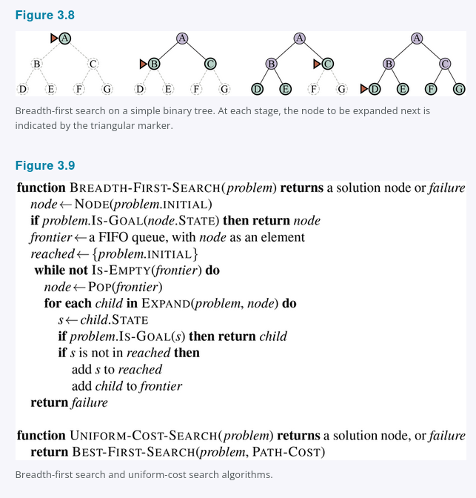

Breadth-first search always finds a solution with a minimal number of actions, because when it is generating nodes at depth d, it has already generated all the nodes at depth d - 1, so if one of them were a solution, it would have been found. That means it is cost-optimal for problems where all actions have the same cost, but not for problems that don’t have that property. It is complete in either case. In terms of time and space, imagine searching a uniform tree where every state has b successors. The root of the search tree generates b nodes, each of which generates b more nodes, for a total of b^2 at the second level. Each of these generates b more nodes, yielding b^3 nodes at the third level, and so on. Now suppose that the solution is at depth d. Then the total number of nodes generated is
1 + b + b^2 + b^3 + ... + b^d = O(b^d)
All the nodes remain in memory, so both time and space complexity are O(b^d). Exponential bounds like that are scary. As a typical real-world example, consider a problem with branching factor b = 10, processing speed 1 million nodes/second, and memory requirements of 1 Kbyte/node. A search to depth d = 10 would take less than 3 hours, but would require 10 terabytes of memory. The memory requirements are a bigger problem for breadth-first search than the execution time. But time is still an important factor. At depth d = 14, even with infinite memory, the search would take 3.5 years. In general, exponential-complexity search problems cannot be solved by uninformed search for any but the smallest instances.

3.4.2 Dijkstra’s algorithm or uniform-cost search
When actions have different costs, an obvious choice is to use best-first search where the evaluation function is the cost of the path from the root to the current node. This is called Dijkstra’s algorithm by the theoretical computer science community, and uniform-cost search by the AI community. The idea is that while breadth-first search spreads out in waves of uniform depth, first depth 1, then depth 2, and so on, uniform-cost search spreads out in waves of uniform path-cost. The algorithm can be implemented as a call to Best-First-Search with Path-Cost as the evaluation function, as shown in Figure 3.9.
Consider Figure 3.10, where the problem is to get from Sibiu to Bucharest. The successors of Sibiu are Rimnicu Vilcea and Fagaras, with costs 80 and 99, respectively. The least-cost node, Rimnicu Vilcea, is expanded next, adding Pitesti with cost 80 + 97 = 177. The least-cost node is now Fagaras, so it is expanded, adding Bucharest with cost 99 + 211 = 310. Bucharest is the goal, but the algorithm tests for goals only when it expands a node, not when it generates a node, so it has not yet detected that this is a path to the goal.
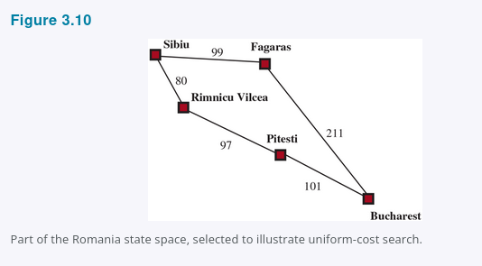

The algorithm continues on, choosing Pitesti for expansion next and adding a second path to Bucharest with cost 80 + 97 + 101 = 278. It has a lower cost, so it replaces the previous path in reached and is added to the frontier. It turns out this node now has the lowest cost, so it is considered next, found to be a goal, and returned. Note that if we had checked for a goal upon generating a node rather than when expanding the lowest-cost node, then we would have returned a higher-cost path, the one through Fagaras.
The complexity of uniform-cost search is characterized in terms of C^, the cost of the optimal solution, and ε, a lower bound on the cost of each action, with ε > 0. Then the algorithm’s worst-case time and space complexity is O(b^(1 + ⌊C^/ε⌋)), which can be much greater than b^d. This is because uniform-cost search can explore large trees of actions with low costs before exploring paths involving a high-cost and perhaps useful action. When all action costs are equal, b^(1 + ⌊C^*/ε⌋) is just b^(d + 1), and uniform-cost search is similar to breadth-first search.
Uniform-cost search is complete and is cost-optimal, because the first solution it finds will have a cost that is at least as low as the cost of any other node in the frontier. Uniform-cost search considers all paths systematically in order of increasing cost, never getting caught going down a single infinite path assuming that all action costs are > ε > 0.

3.4.3 Depth-first search and the problem of memory
Depth-first search always expands the deepest node in the frontier first. It could be implemented as a call to Best-First-Search where the evaluation function f is the negative of the depth. However, it is usually implemented not as a graph search but as a tree-like search that does not keep a table of reached states. The progress of the search is illustrated in Figure 3.11; search proceeds immediately to the deepest level of the search tree, where the nodes have no successors. The search then “backs up” to the next deepest node that still has unexpanded successors. Depth-first search is not cost-optimal; it returns the first solution it finds, even if it is not cheapest.
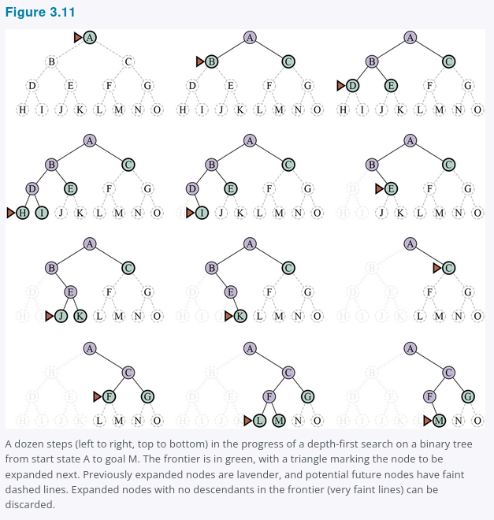

For finite state spaces that are trees it is efficient and complete; for acyclic state spaces it may end up expanding the same state many times via different paths, but will eventually systematically explore the entire space.
In cyclic state spaces it can get stuck in an infinite loop; therefore some implementations of depth-first search check each new node for cycles. Finally, in infinite state spaces, depth-first search is not systematic: it can get stuck going down an infinite path, even if there are no cycles. Thus, depth-first search is incomplete.
With all this bad news, why would anyone consider using depth-first search rather than breadth-first or best-first? The answer is that for problems where a tree-like search is feasible, depth-first search has much smaller needs for memory. We don’t keep a reached table at all, and the frontier is very small: think of the frontier in breadth-first search as the surface of an ever-expanding sphere, while the frontier in depth-first search is just a radius of the sphere.
For a finite tree-shaped state-space like the one in Figure 3.11, a depth-first tree-like search takes time proportional to the number of states, and has memory complexity of only O(bm), where b is the branching factor and m is the maximum depth of the tree. Some problems that would require exabytes of memory with breadth-first search can be handled with only kilobytes using depth-first search. Because of its parsimonious use of memory, depth-first tree-like search has been adopted as the basic workhorse of many areas of AI, including constraint satisfaction (Chapter 6), propositional satisfiability (Chapter 7), and logic programming (Chapter 9).
A variant of depth-first search called backtracking search uses even less memory. See Chapter 6 for more details. In backtracking, only one successor is generated at a time rather than all successors; each partially expanded node remembers which successor to generate next. In addition, successors are generated by modifying the current state description directly rather than allocating memory for a brand-new state. This reduces the memory requirements to just one state description and a path of O(m) actions; a significant savings over O(bm) states for depth-first search. With backtracking we also have the option of maintaining an efficient set data structure for the states on the current path, allowing us to check for a cyclic path in O(1) time rather than O(m). For backtracking to work, we must be able to undo each action when we backtrack. Backtracking is critical to the success of many problems with large state descriptions, such as robotic assembly.

3.4.4 Depth-limited and iterative deepening search
To keep depth-first search from wandering down an infinite path, we can use depth-limited search, a version of depth-first search in which we supply a depth limit, ℓ, and treat all nodes at depth ℓ as if they had no successors see Figure 3.12. The time complexity is O(b^ℓ) and the space complexity is O(bℓ). Unfortunately, if we make a poor choice for ℓ the algorithm will fail to reach the solution, making it incomplete again.
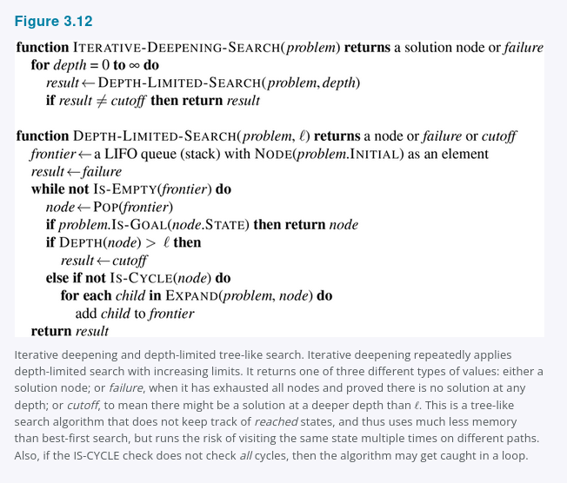

Since depth-first search is a tree-like search, we can’t keep it from wasting time on redundant paths in general, but we can eliminate cycles at the cost of some computation time. If we look only a few links up in the parent chain we can catch most cycles; longer cycles are handled by the depth limit.
Sometimes a good depth limit can be chosen based on knowledge of the problem. For example, on the map of Romania there are 20 cities. Therefore, ℓ = 19 is a valid limit. But if we studied the map carefully, we would discover that any city can be reached from any other city in at most 9 actions. This number, known as the diameter of the state-space graph, gives us a better depth limit, which leads to a more efficient depth-limited search. However, for most problems we will not know a good depth limit until we have solved the problem.
Iterative deepening search solves the problem of picking a good value for ℓ by trying all values: first 0, then 1, then 2, and so on, until either a solution is found, or the depth-limited search returns the failure value rather than the cutoff value. The algorithm is shown in Figure 3.12. Iterative deepening combines many of the benefits of depth-first and breadth-first search. Like depth-first search, its memory requirements are modest: O(bd) when there is a solution, or O(bm) on finite state spaces with no solution. Like breadth-first search, iterative deepening is optimal for problems where all actions have the same cost, and is complete on finite acyclic state spaces, or on any finite state space when we check nodes for cycles all the way up the path.
The time complexity is O(b^d) when there is a solution, or O(b^m) when there is none. Each iteration of iterative deepening search generates a new level, in the same way that breadth-first search does, but breadth-first does this by storing all nodes in memory, while iterative-deepening does it by repeating the previous levels, thereby saving memory at the cost of more time. Figure 3.13 shows four iterations of iterative-deepening search on a binary search tree, where the solution is found on the fourth iteration.

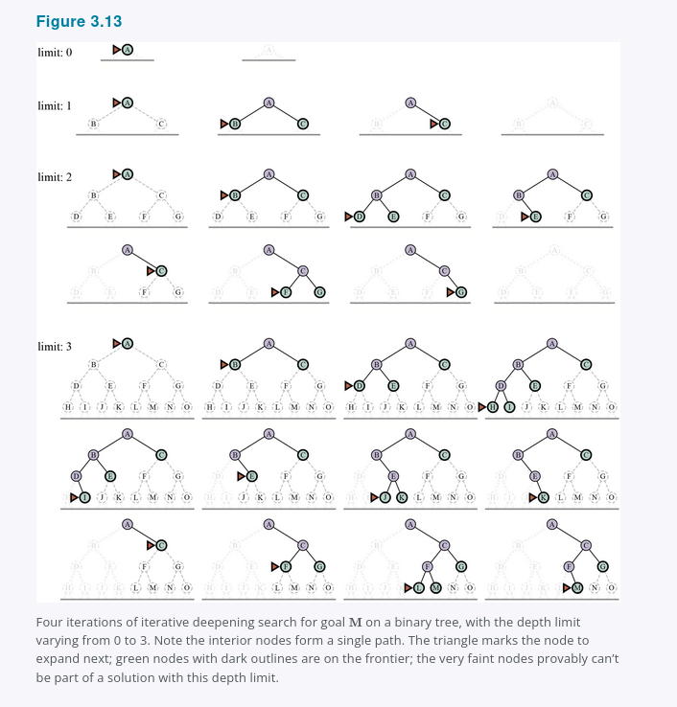

Iterative deepening search may seem wasteful because states near the top of the search tree are re-generated multiple times. But for many state spaces, most of the nodes are in the bottom level, so it does not matter much that the upper levels are repeated. In an iterative deepening search, the nodes on the bottom level depth d are generated once, those on the next-to-bottom level are generated twice, and so on, up to the children of the root, which are generated d times. So the total number of nodes generated in the worst case is
N(IDS) = (d)b^1 + (d - 1)b^2 + (d - 2)b^3 ... + b^d
which gives a time complexity of O(b^d) asymptotically the same as breadth-first search. For example, if b = 10 and d = 5, the numbers are
N(IDS) = 50 + 400 + 3,000 + 20,000 + 100,000 = 123,450
N(BFS) = 10 + 100 + 1,000 + 10,000 + 100,000 = 111,110
If you are really concerned about the repetition, you can use a hybrid approach that runs breadth-first search until almost all the available memory is consumed, and then runs iterative deepening from all the nodes in the frontier. In general, iterative deepening is the preferred uninformed search method when the search state space is larger than can fit in memory and the depth of the solution is not known.

3.4.5 Bidirectional search
The algorithms we have covered so far start at an initial state and can reach any one of multiple possible goal states. An alternative approach called bidirectional search simultaneously searches forward from the initial state and backwards from the goal state(s), hoping that the two searches will meet. The motivation is that b^d/2 + b^d/2 is much less than b^d e.g., 50,000 times less when b = d = 10.
For this to work, we need to keep track of two frontiers and two tables of reached states, and we need to be able to reason backwards: if state s′ is a successor of s in the forward direction, then we need to know that s is a successor of s′ in the backward direction. We have a solution when the two frontiers collide.
There are many different versions of bidirectional search, just as there are many different unidirectional search algorithms. In this section, we describe bidirectional best-first search. Although there are two separate frontiers, the node to be expanded next is always one with a minimum value of the evaluation function, across either frontier. When the evaluation function is the path cost, we get bidirectional uniform-cost search, and if the cost of the optimal path is C^, then no node with cost > C^/2 will be expanded. This can result in a considerable speedup.
The general best-first bidirectional search algorithm is shown in Figure 3.14. We pass in two versions of the problem and the evaluation function, one in the forward direction subscript F and one in the backward direction subscript B. When the evaluation function is the path cost, we know that the first solution found will be an optimal solution, but with different evaluation functions that is not necessarily true. Therefore, we keep track of the best solution found so far, and might have to update that several times before the Terminated test proves that there is no possible better solution remaining.
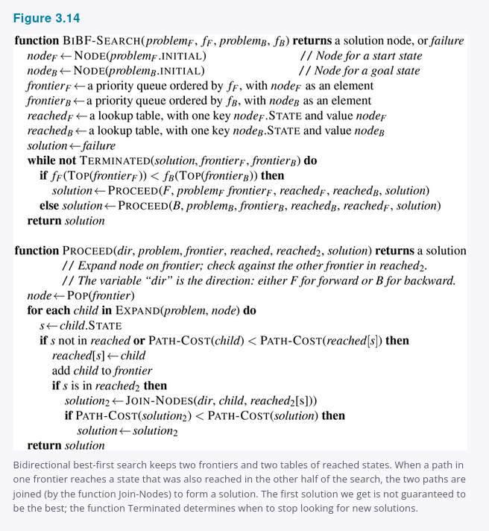

3.4.6 Comparing uninformed search algorithms
Figure 3.15 compares uninformed search algorithms in terms of the four evaluation criteria set forth in Section 3.3.4. This comparison is for tree-like search versions which don’t check for repeated states. For graph searches which do check, the main differences are that depth-first search is complete for finite state spaces, and the space and time complexities are bounded by the size of the state space, the number of vertices and edges, |V| + |E|.
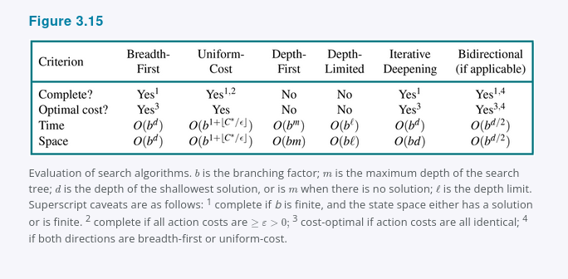

3.5 Informed (Heuristic) Search Strategies
This section shows how an informed search strategy, one that uses domain-specific hints about the location of goals, can find solutions more efficiently than an uninformed strategy. The hints come in the form of a heuristic function, denoted h(n):
h(n) = estimated cost of the cheapest path from the state at node n to a goal state.
For example, in route-finding problems, we can estimate the distance from the current state to a goal by computing the straight-line distance on the map between the two points. We study heuristics and where they come from in more detail in Section 3.6.

3.5.1 Greedy best-first search
Greedy best-first search is a form of best-first search that expands first the node with the lowest h(n) value, the node that appears to be closest to the goal, on the grounds that this is likely to lead to a solution quickly. So the evaluation function f(n) = h(n).
Let us see how this works for route-finding problems in Romania; we use the straight-line distance heuristic, which we will call hSLD. If the goal is Bucharest, we need to know the straight-line distance to Bucharest, which are shown in Figure 3.16. For example, hSLD(Arad) = 366. Notice that the values of hSLD cannot be computed from the problem description itself that is, the ACTIONS and RESULT functions. Moreover, it takes a certain amount of world knowledge to know that hSLD is correlated with actual road distances and is, therefore, a useful heuristic.
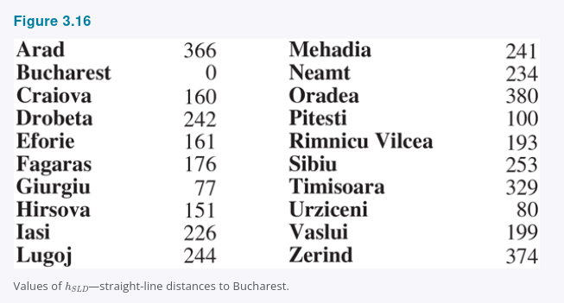
Figure 3.17 shows the progress of a greedy best-first search using hSLD to find a path from Arad to Bucharest. The first node to be expanded from Arad will be Sibiu because the heuristic says it is closer to Bucharest than is either Zerind or Timisoara. The next node to be expanded will be Fagaras because it is now closest according to the heuristic. Fagaras in turn generates Bucharest, which is the goal. For this particular problem, greedy best-first search using hSLD finds a solution without ever expanding a node that is not on the solution path. The solution it found does not have optimal cost, however: the path via Sibiu and Fagaras to Bucharest is 32 miles longer than the path through Rimnicu Vilcea and Pitesti. This is why the algorithm is called “greedy”, on each iteration it tries to get as close to a goal as it can, but greediness can lead to worse results than being careful.
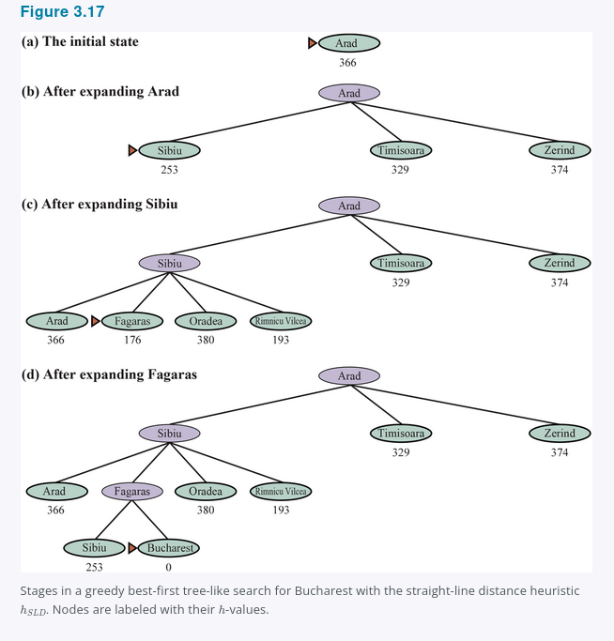

Greedy best-first graph search is complete in finite state spaces, but not in infinite ones. The worst-case time and space complexity is O(|V|). With a good heuristic function, however, the complexity can be reduced substantially, on certain problems reaching O(bm).

3.5.2 A* search
The most common informed search algorithm is A search* pronounced “A-star search”, a best-first search that uses the evaluation function
f(n) = g(n) + h(n)
where g(n) is the path cost from the initial state to node n, and h(n) is the estimated cost of the shortest path from n to a goal state, so we have
f(n) = estimated cost of the best path that continues from n to a goal.
In Figure 3.18, we show the progress of an A* search with the goal of reaching Bucharest. The values of g are computed from the action costs in Figure 3.1, and the values of hSLD are given in Figure 3.16. Notice that Bucharest first appears on the frontier at step e, but it is not selected for expansion and thus not detected as a solution because at f = 450 it is not the lowest-cost node on the frontier, that would be Pitesti, at f = 417. Another way to say this is that there might be a solution through Pitesti whose cost is as low as 417, so the algorithm will not settle for a solution that costs 450. At step f, a different path to Bucharest is now the lowest-cost node, at f = 418, so it is selected and detected as the optimal solution.
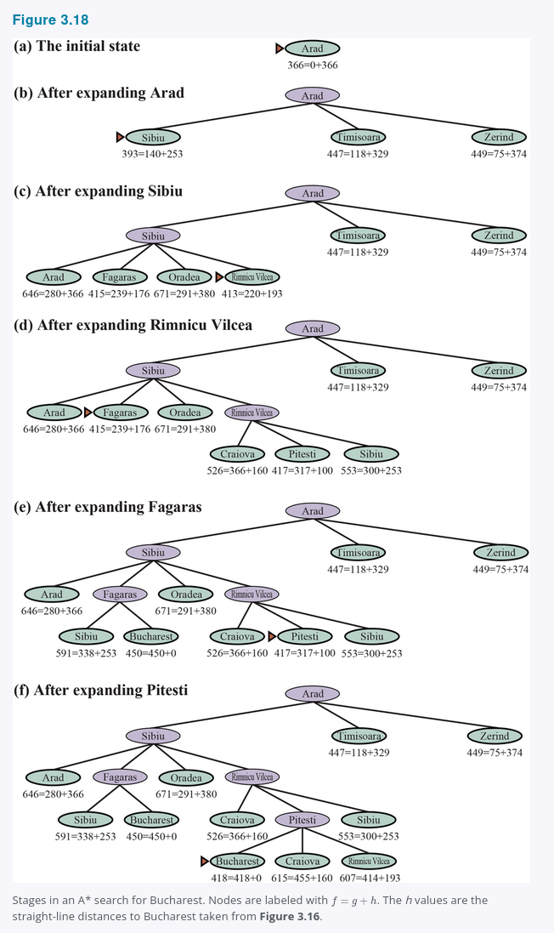

A* search is complete. Whether A* is cost-optimal depends on certain properties of the heuristic. A key property is admissibility: an admissible heuristic is one that never overestimates the cost to reach a goal. An admissible heuristic is therefore optimistic. With an admissible heuristic, A* is cost-optimal, which we can show with a proof by contradiction. Suppose the optimal path has cost C^, but the algorithm returns a path with cost C > C^. Then there must be some node n which is on the optimal path and is unexpanded because if all the nodes on the optimal path had been expanded, then we would have returned that optimal solution. So then, using the notation g^(n) to mean the cost of the optimal path from the start to n, and h^(n) to mean the cost of the optimal path from n to the nearest goal, we have:
f(n) > C* (otherwise n would have been expanded)
f(n) = g(n) + h(n) (by definition)
f(n) = g*(n) + h(n) (because n is on an optimal path)
f(n) <= g*(n) + h*(n) (because of admissibility, h(n) <= h*(n))
f(n) <= C* (by definition, C* = g*(n) + h*(n))
The first and last lines form a contradiction, so the supposition that the algorithm could return a suboptimal path must be wrong, it must be that A* returns only cost-optimal paths.
A slightly stronger property is called consistency. A heuristic h(n) is consistent if, for every node n and every successor n′ of n generated by an action a, we have:
h(n) <= c(n, a, n′) + h(n′).
This is a form of the triangle inequality, which stipulates that a side of a triangle cannot be longer than the sum of the other two sides see Figure 3.19. An example of a consistent heuristic is the straight-line distance hSLD that we used in getting to Bucharest.
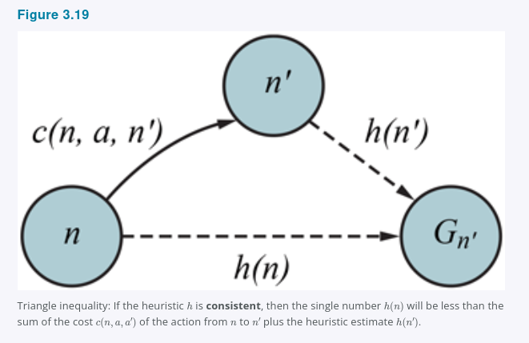

Every consistent heuristic is admissible but not vice versa, so with a consistent heuristic, A* is cost-optimal. In addition, with a consistent heuristic, the first time we reach a state it will be on an optimal path, so we never have to re-add a state to the frontier, and never have to change an entry in reached. But with an inconsistent heuristic, we may end up with multiple paths reaching the same state, and if each new path has a lower path cost than the previous one, then we will end up with multiple nodes for that state in the frontier, costing us both time and space. Because of that, some implementations of A* take care to only enter a state into the frontier once, and if a better path to the state is found, all the successors of the state are updated which requires that nodes have child pointers as well as parent pointers. These complications have led many implementers to avoid inconsistent heuristics, but Felner et al. 2011 argues that the worst effects rarely happen in practice, and one shouldn’t be afraid of inconsistent heuristics.
With an inadmissible heuristic, A* may or may not be cost-optimal. Here are two cases where it is: First, if there is even one cost-optimal path on which h(n) is admissible for all nodes n on the path, then that path will be found, no matter what the heuristic says for states off the path. Second, if the optimal solution has cost C^, and the second-best has cost C2, and if h(n) overestimates some costs, but never by more than C2 - C^, then A* is guaranteed to return cost-optimal solutions.

3.5.3 Search contours
A useful way to visualize a search is to draw contours in the state space, just like the contours in a topographic map. Figure 3.20 shows an example. Inside the contour labeled 400, all nodes have f(n) = g(n) + h(n) <= 400, and so on. Then, because A* expands the frontier node of lowest f-cost, we can see that an A* search fans out from the start node, adding nodes in concentric bands of increasing f-cost.

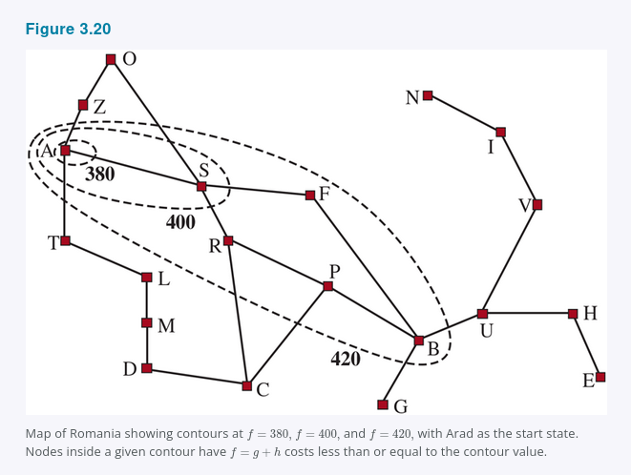

With uniform-cost search, we also have contours, but of g-cost, not g + h. The contours with uniform-cost search will be “circular” around the start state, spreading out equally in all directions with no preference towards the goal. With A* search using a good heuristic, the g + h bands will stretch toward a goal state as in Figure 3.20 and become more narrowly focused around an optimal path.
It should be clear that as you extend a path, the g costs are monotonic: the path cost always increases as you go along a path, because action costs are always positive. Therefore you get concentric contour lines that don’t cross each other, and if you choose to draw the lines fine enough, you can put a line between any two nodes on any path.
But it is not obvious whether the f = g + h cost will monotonically increase. As you extend a path from n to n′, the cost goes from g(n) + h(n) to g(n) + c(n, a, n′) + h(n′). Canceling out the g(n) term, we see that the path’s cost will be monotonically increasing if and only if h(n) <= c(n, a, n′) + h(n′); in other words if and only if the heuristic is consistent. But note that a path might contribute several nodes in a row with the same g(n) + h(n) score; this will happen whenever the decrease in h is exactly equal to the action cost just taken for example, in a grid problem, when n is in the same row as the goal and you take a step towards the goal, g is increased by 1 and h is decreased by 1. If C^* is the cost of the optimal solution path, then we can say the following:
- A* expands all nodes that can be reached from the initial state on a path where every node on the path has f(n) < C^*. We say these are surely expanded nodes.
- A* might then expand some of the nodes right on the “goal contour” where f(n) = C^* before selecting a goal node.
- A* expands no nodes with f(n) > C^*.
We say that A* with a consistent heuristic is optimally efficient in the sense that any algorithm that extends search paths from the initial state, and uses the same heuristic information, must expand all nodes that are surely expanded by A* because any one of them could have been part of an optimal solution. Among the nodes with f(n) = C^*, one algorithm could get lucky and choose the optimal one first while another algorithm is unlucky; we don’t consider this difference in defining optimal efficiency.
A* is efficient because it prunes away search tree nodes that are not necessary for finding an optimal solution. In Figure 3.18(b) we see that Timisoara has f = 447 and Zerind has f = 449. Even though they are children of the root and would be among the first nodes expanded by uniform-cost or breadth-first search, they are never expanded by A* search because the solution with f = 418 is found first. The concept of pruning, eliminating possibilities from consideration without having to examine them, is important for many areas of AI.
That A* search is complete, cost-optimal, and optimally efficient among all such algorithms is rather satisfying. Unfortunately, it does not mean that A* is the answer to all our searching needs. The catch is that for many problems, the number of nodes expanded can be exponential in the length of the solution. For example, consider a version of the vacuum world with a super-powerful vacuum that can clean up any one square at a cost of 1 unit, without even having to visit the square; in that scenario, squares can be cleaned in any order. With N initially dirty squares, there are 2^N states where some subset has been cleaned; all of those states are on an optimal solution path, and hence satisfy f(n) < C^, so all of them would be visited by A.

3.5.4 Satisficing search: Inadmissible heuristics and weighted A*
A* search has many good qualities, but it expands a lot of nodes. We can explore fewer nodes taking less time and space if we are willing to accept solutions that are suboptimal, but are “good enough”, what we call satisficing solutions. If we allow A* search to use an inadmissible heuristic, one that may overestimate, then we risk missing the optimal solution, but the heuristic can potentially be more accurate, thereby reducing the number of nodes expanded. For example, road engineers know the concept of a detour index, which is a multiplier applied to the straight-line distance to account for the typical curvature of roads. A detour index of 1.3 means that if two cities are 10 miles apart in straight-line distance, a good estimate of the best path between them is 13 miles. For most localities, the detour index ranges between 1.2 and 1.6.
We can apply this idea to any problem, not just ones involving roads, with an approach called weighted A search* where we weight the heuristic value more heavily, giving us the evaluation function f(n) = g(n) + W x h(n), for some W > 1.
Figure 3.21 shows a search problem on a grid world. In a, an A* search finds the optimal solution, but has to explore a large portion of the state space to find it. In b, a weighted A* search finds a solution that is slightly costlier, but the search time is much faster. We see that the weighted search focuses the contour of reached states towards a goal. That means that fewer states are explored, but if the optimal path ever strays outside of the weighted search’s contour as it does in this case, then the optimal path will not be found. In general, if the optimal solution costs C^, a weighted A search will find a solution that costs somewhere between C^* and W x C^; but in practice we usually get results much closer to C^ than W x C^*.

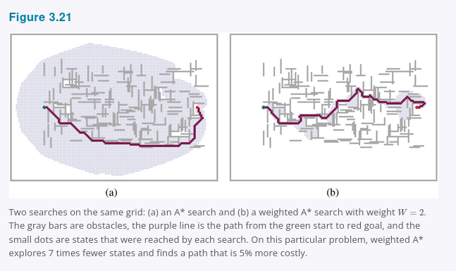

We have considered searches that evaluate states by combining g and h in various ways; weighted A* can be seen as a generalization of the others:
A* search: g(n) + h(n) (W = 1)
Uniform-cost search: g(n) (W = 0)
Greedy best-first search: h(n) (W = infinity)
Weighted A* search: g(n) + W x h(n) (1 < W < infinity)
You could call weighted A* “somewhat-greedy search”: like greedy best-first search, it focuses the search towards a goal; on the other hand, it won’t ignore the path cost completely, and will suspend a path that is making little progress at great cost.
There are a variety of suboptimal search algorithms, which can be characterized by the criteria for what counts as “good enough.” In bounded suboptimal search, we look for a solution that is guaranteed to be within a constant factor W of the optimal cost. Weighted A* provides this guarantee. In bounded-cost search, we look for a solution whose cost is less than some constant C. And in unbounded-cost search, we accept a solution of any cost, as long as we can find it quickly.
An example of an unbounded-cost search algorithm is speedy search, which is a version of greedy best-first search that uses as a heuristic the estimated number of actions required to reach a goal, regardless of the cost of those actions. Thus, for problems where all actions have the same cost it is the same as greedy best-first search, but when actions have different costs, it tends to lead the search to find a solution quickly, even if it might have a high cost.

3.5.5 Memory-bounded search
The main issue with A* is its use of memory. In this section we’ll cover some implementation tricks that save space, and then some entirely new algorithms that take better advantage of the available space.
Memory is split between the frontier and the reached states. In our implementation of best-first search, a state that is on the frontier is stored in two places: as a node in the frontier so we can decide what to expand next and as an entry in the table of reached states so we know if we have visited the state before. For many problems such as exploring a grid, this duplication is not a concern, because the size of frontier is much smaller than reached, so duplicating the states in the frontier requires a comparatively trivial amount of memory. But some implementations keep a state in only one of the two places, saving a bit of space at the cost of complicating and perhaps slowing down the algorithm.
Another possibility is to remove states from reached when we can prove that they are no longer needed. For some problems, we can use the separation property Figure 3.6, along with the prohibition of U-turn actions, to ensure that all actions either move outwards from the frontier or onto another frontier state. In that case, we need only check the frontier for redundant paths, and we can eliminate the reached table.
For other problems, we can keep reference counts of the number of times a state has been reached, and remove it from the reached table when there are no more ways to reach the state. For example, on a grid world where each state can be reached only from its four neighbors, once we have reached a state four times, we can remove it from the table.
Now let’s consider new algorithms that are designed to conserve memory usage.
Beam search limits the size of the frontier. The easiest approach is to keep only the k nodes with the best f-scores, discarding any other expanded nodes. This of course makes the search incomplete and suboptimal, but we can choose k to make good use of available memory, and the algorithm executes fast because it expands fewer nodes. For many problems it can find good near-optimal solutions. You can think of uniform-cost or A* search as spreading out everywhere in concentric contours, and think of beam search as exploring only a focused portion of those contours, the portion that contains the k best candidates.
An alternative version of beam search doesn’t keep a strict limit on the size of the frontier but instead keeps every node whose f-score is within δ of the best f-score. That way, when there are a few strong-scoring nodes only a few will be kept, but if there are no strong nodes then more will be kept until a strong one emerges.
Iterative-deepening A search* IDA* is to A* what iterative-deepening search is to depth-first: IDA* gives us the benefits of A* without the requirement to keep all reached states in memory, at a cost of visiting some states multiple times. It is a very important and commonly used algorithm for problems that do not fit in memory.
In standard iterative deepening the cutoff is the depth, which is increased by one each iteration. In IDA* the cutoff is the f-cost g + h; at each iteration, the cutoff value is the smallest f-cost of any node that exceeded the cutoff on the previous iteration. In other words, each iteration exhaustively searches an f-contour, finds a node just beyond that contour, and uses that node’s f-cost as the next contour. For problems like the 8-puzzle where each path’s f-cost is an integer, this works very well, resulting in steady progress towards the goal each iteration. If the optimal solution has cost C^, then there can be no more than C^ iterations for example, no more than 31 iterations on the hardest 8-puzzle problems. But for a problem where every node has a different f-cost, each new contour might contain only one new node, and the number of iterations could be equal to the number of states.
Recursive best-first search RBFS Figure 3.22 attempts to mimic the operation of standard best-first search, but using only linear space. RBFS resembles a recursive depth-first search, but rather than continuing indefinitely down the current path, it uses the f_limit variable to keep track of the f-value of the best alternative path available from any ancestor of the current node. If the current node exceeds this limit, the recursion unwinds back to the alternative path. As the recursion unwinds, RBFS replaces the f-value of each node along the path with a backed-up value, the best f-value of its children. In this way, RBFS remembers the f-value of the best leaf in the forgotten subtree and can therefore decide whether it’s worth reexpanding the subtree at some later time. Figure 3.23 shows how RBFS reaches Bucharest.

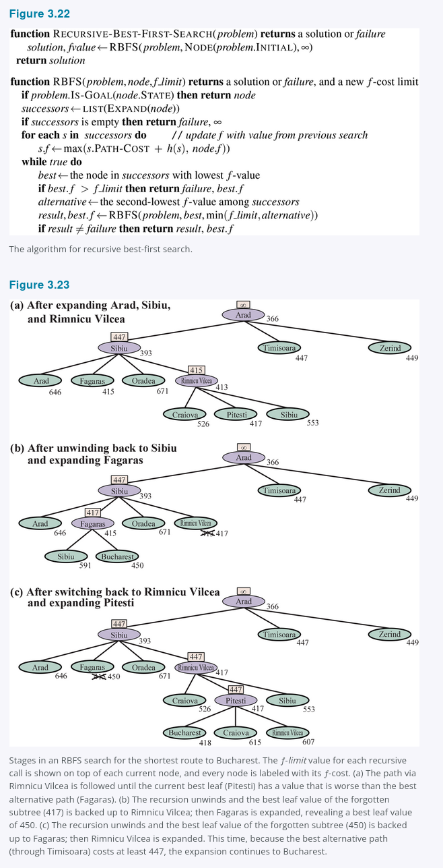

RBFS is somewhat more efficient than IDA*, but still suffers from excessive node regeneration. In the example in Figure 3.23, RBFS follows the path via Rimnicu Vilcea, then “changes its mind” and tries Fagaras, and then changes its mind back again. These mind changes occur because every time the current best path is extended, its f-value is likely to increase, h is usually less optimistic for nodes closer to a goal. When this happens, the second-best path might become the best path, so the search has to backtrack to follow it. Each mind change corresponds to an iteration of IDA* and could require many reexpansions of forgotten nodes to recreate the best path and extend it one more node.
RBFS is optimal if the heuristic function h(n) is admissible. Its space complexity is linear in the depth of the deepest optimal solution, but its time complexity is rather difficult to characterize: it depends both on the accuracy of the heuristic function and on how often the best path changes as nodes are expanded. It expands nodes in order of increasing f-score, even if f is nonmonotonic.
IDA* and RBFS suffer from using too little memory. Between iterations, IDA* retains only a single number: the current f-cost limit. RBFS retains more information in memory, but it uses only linear space: even if more memory were available, RBFS has no way to make use of it. Because they forget most of what they have done, both algorithms may end up reexploring the same states many times over.
It seems sensible, therefore, to determine how much memory we have available, and allow an algorithm to use all of it. Two algorithms that do this are MA* memory-bounded A* and SMA* simplified MA*. SMA* is, well, simpler, so we will describe it. SMA* proceeds just like A*, expanding the best leaf until memory is full. At this point, it cannot add a new node to the search tree without dropping an old one. SMA* always drops the worst leaf node, the one with the highest f-value. Like RBFS, SMA* then backs up the value of the forgotten node to its parent. In this way, the ancestor of a forgotten subtree knows the quality of the best path in that subtree. With this information, SMA* regenerates the subtree only when all other paths have been shown to look worse than the path it has forgotten. Another way of saying this is that if all the descendants of a node n are forgotten, then we will not know which way to go from n, but we will still have an idea of how worthwhile it is to go anywhere from n.
The complete algorithm is described in the online code repository accompanying this book. There is one subtlety worth mentioning. We said that SMA* expands the best leaf and deletes the worst leaf. What if all the leaf nodes have the same f-value? To avoid selecting the same node for deletion and expansion, SMA* expands the newest best leaf and deletes the oldest worst leaf. These coincide when there is only one leaf, but in that case, the current search tree must be a single path from root to leaf that fills all of memory. If the leaf is not a goal node, then even if it is on an optimal solution path, that solution is not reachable with the available memory. Therefore, the node can be discarded exactly as if it had no successors.
SMA* is complete if there is any reachable solution, that is, if d, the depth of the shallowest goal node, is less than the memory size expressed in nodes. It is optimal if any optimal solution is reachable; otherwise, it returns the best reachable solution. In practical terms, SMA* is a fairly robust choice for finding optimal solutions, particularly when the state space is a graph, action costs are not uniform, and node generation is expensive compared to the overhead of maintaining the frontier and the reached set.
On very hard problems, however, it will often be the case that SMA* is forced to switch back and forth continually among many candidate solution paths, only a small subset of which can fit in memory. This resembles the problem of thrashing in disk paging systems. Then the extra time required for repeated regeneration of the same nodes means that problems that would be practically solvable by A*, given unlimited memory, become intractable for SMA*. That is to say, memory limitations can make a problem intractable from the point of view of computation time. Although no current theory explains the tradeoff between time and memory, it seems that this is an inescapable problem. The only way out is to drop the optimality requirement.

3.5.6 Bidirectional heuristic search
With bidirectional best-first search we could also try using f(n) = g(n) + h(n), but unfortunately there is no guarantee that this would lead to an optimal-cost solution, nor that it would be optimally efficient, even with an admissible heuristic. With bidirectional search, it turns out that it is not individual nodes but rather pairs of nodes one from each frontier that can be proved to be surely expanded, so any proof of efficiency will have to consider pairs of nodes Eckerle et al., 2017.
We’ll start with some new notation. We use fF(n) = gF(n) + hF(n) for nodes going in the forward direction with the initial state as root and fB(n) = gB(n) + hB(n) for nodes in the backward direction with a goal state as root. Although both forward and backward searches are solving the same problem, they have different evaluation functions because, for example, the heuristics are different depending on whether you are striving for the goal or for the initial state. We’ll assume admissible heuristics.
Consider a forward path from the initial state to a node m and a backward path from the goal to a node n. We can define a lower bound on the cost of a solution that follows the path from the initial state to m, then somehow gets to n, then follows the path to the goal as
lb(m, n) = max(gF(m) + gB(n), fF(m), fB(n))
In other words, the cost of such a path must be at least as large as the sum of the path costs of the two parts because the remaining connection between them must have nonnegative cost, and the cost must also be at least as much as the estimated f cost of either part because the heuristic estimates are optimistic. Given that, the theorem is that for any pair of nodes m, n with lb(m, n) less than the optimal cost C^*, we must expand either m or n, because the path that goes through both of them is a potential optimal solution. The difficulty is that we don’t know for sure which node is best to expand, and therefore no bidirectional search algorithm can be guaranteed to be optimally efficient, any algorithm might expand up to twice the minimum number of nodes if it always chooses the wrong member of a pair to expand first. Some bidirectional heuristic search algorithms explicitly manage a queue of (m, n) pairs, but we will stick with bidirectional best-first search Figure 3.14, which has two frontier priority queues, and give it an evaluation function that mimics the lb criteria:
f2(n) = max(2g(n), g(n) + h(n))
The node to expand next will be the one that minimizes this f2 value; the node can come from either frontier. This f2 function guarantees that we will never expand a node from either frontier with g(n) > C^/2. We say the two halves of the search “meet in the middle” in the sense that when the two frontiers touch, no node inside of either frontier has a path cost greater than the bound C^/2. Figure 3.24 works through an example bidirectional search.
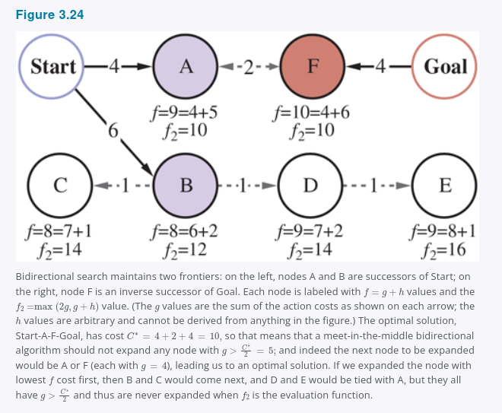

We have described an approach where the hF heuristic estimates the distance to the goal or, when the problem has multiple goal states, the distance to the closest goal and hB estimates the distance to the start. This is called a front-to-end search. An alternative, called front-to-front search, attempts to estimate the distance to the other frontier. Clearly, if a frontier has millions of nodes, it would be inefficient to apply the heuristic function to every one of them and take the minimum. But it can work to sample a few nodes from the frontier. In certain specific problem domains it is possible to summarize the frontier, for example, in a grid search problem, we can incrementally compute a bounding box of the frontier, and use as a heuristic the distance to the bounding box.
Bidirectional search is sometimes more efficient than unidirectional search, sometimes not. In general, if we have a very good heuristic, then A* search produces search contours that are focused on the goal, and adding bidirectional search does not help much. With an average heuristic, bidirectional search that meets in the middle tends to expand fewer nodes and is preferred. In the worst case of a poor heuristic, the search is no longer focused on the goal, and bidirectional search has the same asymptotic complexity as A*. Bidirectional search with the f2 evaluation function and an admissible heuristic h is complete and optimal.

3.6 Heuristic Functions
In this section, we look at how the accuracy of a heuristic affects search performance, and also consider how heuristics can be invented. As our main example we’ll return to the 8-puzzle. As mentioned in Section 3.2, the object of the puzzle is to slide the tiles horizontally or vertically into the empty space until the configuration matches the goal configuration (Figure 3.25).

Figure 3.25
A typical instance of the 8-puzzle. The shortest solution is 26 actions long.
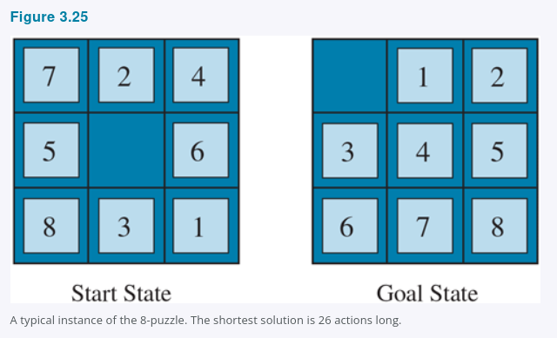

There are 9!/2 = 181,400 reachable states in an 8-puzzle, so a search could easily keep them all in memory. But for the 15-puzzle, there are 16!/2 states, over 10 trillion, so to search that space we will need the help of a good admissible heuristic function. There is a long history of such heuristics for the 15-puzzle; here are two commonly used candidates:
- h1 = the number of misplaced tiles blank not included. For Figure 3.25, all eight tiles are out of position, so the start state has h1 = 8. h1 is an admissible heuristic because any tile that is out of place will require at least one move to get it to the right place.
- h2 = the sum of the distances of the tiles from their goal positions. Because tiles cannot move along diagonals, the distance is the sum of the horizontal and vertical distances, sometimes called the city-block distance or Manhattan distance. h2 is also admissible because all any move can do is move one tile one step closer to the goal. Tiles 1 to 8 in the start state of Figure 3.25 give a Manhattan distance of
h2 = 3 + 1 + 2 + 2 + 2 + 3 + 3 + 2 = 18.
As expected, neither of these overestimates the true solution cost, which is 26.

3.6.1 The effect of heuristic accuracy on performance
One way to characterize the quality of a heuristic is the effective branching factor b^. If the total number of nodes generated by A for a particular problem is N and the solution depth is d, then b^* is the branching factor that a uniform tree of depth d would have to have in order to contain N + 1 nodes. Thus,
N + 1 = 1 + b* + (b*)^2 + ... + (b*)^d.
For example, if A* finds a solution at depth 5 using 52 nodes, then the effective branching factor is 1.92. The effective branching factor can vary across problem instances, but usually for a specific domain such as 8-puzzles it is fairly constant across all nontrivial problem instances. Therefore, experimental measurements of b^* on a small set of problems can provide a good guide to the heuristic’s overall usefulness. A well-designed heuristic would have a value of b^* close to 1, allowing fairly large problems to be solved at reasonable computational cost.
Korf and Reid 1998 argue that a better way to characterize the effect of A* pruning with a given heuristic h is that it reduces the effective depth by a constant kh compared to the true depth. This means that the total search cost is O(b^(d - kh)) compared to O(b^d) for an uninformed search. Their experiments on Rubik’s Cube and n-puzzle problems show that this formula gives accurate predictions for total search cost for sampled problem instances across a wide range of solution lengths, at least for solution lengths larger than kh.
For Figure 3.26 we generated random 8-puzzle problems and solved them with an uninformed breadth-first search and with A* search using both h1 and h2, reporting the average number of nodes generated and the corresponding effective branching factor for each search strategy and for each solution length. The results suggest that h2 is better than h1, and both are better than no heuristic at all.
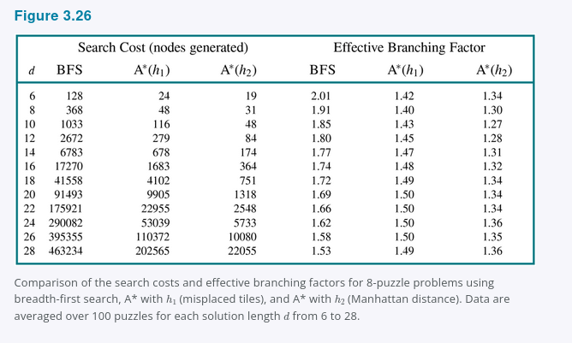

One might ask whether h2 is always better than h1. The answer is “Essentially, yes.” It is easy to see from the definitions of the two heuristics that for any node n, h2(n) >= h1(n). We thus say that h2 dominates h1. Domination translates directly into efficiency: A* using h2 will never expand more nodes than A* using h1 except in the case of breaking ties unluckily. The argument is simple. Recall the observation in Section 3.5 Informed (Heuristic) Search Strategies that every node with f(n) < C^* will surely be expanded. This is the same as saying that every node with h(n) < C^* - g(n) is surely expanded when h is consistent. But because h2 is at least as big as h1 for all nodes, every node that is surely expanded by A* search with h2 is also surely expanded with h1, and h1 might cause other nodes to be expanded as well. Hence, it is generally better to use a heuristic function with higher values, provided it is consistent and that the computation time for the heuristic is not too long.

3.6.2 Generating heuristics from relaxed problems
We have seen that both h1 misplaced tiles and h2 Manhattan distance are fairly good heuristics for the 8-puzzle and that h2 is better. How might one have come up with h2? Is it possible for a computer to invent such a heuristic mechanically?
h1 and h2 are estimates of the remaining path length for the 8-puzzle, but they are also perfectly accurate path lengths for simplified versions of the puzzle. If the rules of the puzzle were changed so that a tile could move anywhere instead of just to the adjacent empty square, then h1 would give the exact length of the shortest solution. Similarly, if a tile could move one square in any direction, even onto an occupied square, then h2 would give the exact length of the shortest solution. A problem with fewer restrictions on the actions is called a relaxed problem. The state-space graph of the relaxed problem is a supergraph of the original state space because the removal of restrictions creates added edges in the graph.
Because the relaxed problem adds edges to the state-space graph, any optimal solution in the original problem is, by definition, also a solution in the relaxed problem; but the relaxed problem may have better solutions if the added edges provide shortcuts. Hence, the cost of an optimal solution to a relaxed problem is an admissible heuristic for the original problem. Furthermore, because the derived heuristic is an exact cost for the relaxed problem, it must obey the triangle inequality and is therefore consistent Section 3.5 Informed (Heuristic) Search Strategies.
If a problem definition is written down in a formal language, it is possible to construct relaxed problems automatically. For example, if the 8-puzzle actions are described as
A tile can move from square X to square Y if
X is adjacent to Y and Y is blank,
we can generate three relaxed problems by removing one or both of the conditions:
a. A tile can move from square X to square Y if X is adjacent to Y.
b. A tile can move from square X to square Y if Y is blank.
c. A tile can move from square X to square Y.
From a, we can derive h2 Manhattan distance. The reasoning is that h2 would be the proper score if we moved each tile in turn to its destination. The heuristic derived from b is discussed in Exercise 3.GASC. From c, we can derive h1 misplaced tiles because it would be the proper score if tiles could move to their intended destination in one action. Notice that it is crucial that the relaxed problems generated by this technique can be solved essentially without search, because the relaxed rules allow the problem to be decomposed into eight independent subproblems. If the relaxed problem is hard to solve, then the values of the corresponding heuristic will be expensive to obtain.
A program called Absolver can generate heuristics automatically from problem definitions, using the “relaxed problem” method and various other techniques Prieditis, 1993. Absolver generated a new heuristic for the 8-puzzle that was better than any preexisting heuristic and found the first useful heuristic for the famous Rubik’s Cube puzzle.
If a collection of admissible heuristics h1 ... hm is available for a problem and none of them is clearly better than the others, which should we choose? As it turns out, we can have the best of all worlds, by defining
h(n) = max {h1(n), ..., hk(n)}.
This composite heuristic picks whichever function is most accurate on the node in question. Because the hi components are admissible, h is admissible and if hi are all consistent, h is consistent. Furthermore, h dominates all of its component heuristics. The only drawback is that h(n) takes longer to compute. If that is an issue, an alternative is to randomly select one of the heuristics at each evaluation, or use a machine learning algorithm to predict which heuristic will be best. Doing this can result in a heuristic that is inconsistent even if every hi is consistent, but in practice it usually leads to faster problem solving.

3.6.3 Generating heuristics from subproblems: Pattern databases
Admissible heuristics can also be derived from the solution cost of a subproblem of a given problem. For example, Figure 3.27 shows a subproblem of the 8-puzzle instance in Figure 3.25. The subproblem involves getting tiles 1, 2, 3, 4, and the blank into their correct positions. Clearly, the cost of the optimal solution of this subproblem is a lower bound on the cost of the complete problem. It turns out to be more accurate than Manhattan distance in some cases.
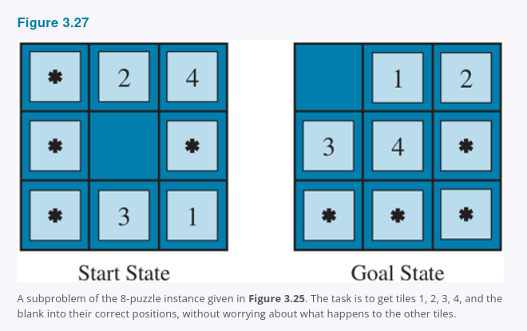

The idea behind pattern databases is to store these exact solution costs for every possible subproblem instance, in our example, every possible configuration of the four tiles and the blank. There will be 9 x 8 x 7 x 6 x 5 = 15,120 patterns in the database. The identities of the other four tiles are irrelevant for the purposes of solving the subproblem, but moves of those tiles do count toward the solution cost of the subproblem. Then we compute an admissible heuristic hDB for each state encountered during a search simply by looking up the corresponding subproblem configuration in the database. The database itself is constructed by searching back from the goal and recording the cost of each new pattern encountered; the expense of this search is amortized over subsequent problem instances, and so makes sense if we expect to be asked to solve many problems.
The choice of tiles 1-2-3-4 to go with the blank is fairly arbitrary; we could also construct databases for 5-6-7-8, for 2-4-6-8, and so on. Each database yields an admissible heuristic, and these heuristics can be combined, as explained earlier, by taking the maximum value. A combined heuristic of this kind is much more accurate than the Manhattan distance; the number of nodes generated when solving random 15-puzzles can be reduced by a factor of 1000. However, with each additional database there are diminishing returns and increased memory and computation costs.
One might wonder whether the heuristics obtained from the 1-2-3-4 database and the 5-6-7-8 could be added, since the two subproblems seem not to overlap. Would this still give an admissible heuristic? The answer is no, because the solutions of the 1-2-3-4 subproblem and the 5-6-7-8 subproblem for a given state will almost certainly share some moves, it is unlikely that 1-2-3-4 can be moved into place without touching 5-6-7-8, and vice versa. But what if we don’t count those moves, what if we don’t abstract the other tiles to stars, but rather make them disappear? That is, we record not the total cost of solving the 1-2-3-4 subproblem, but just the number of moves involving 1-2-3-4. Then the sum of the two costs is still a lower bound on the cost of solving the entire problem. This is the idea behind disjoint pattern databases. With such databases, it is possible to solve random 15-puzzles in a few milliseconds, the number of nodes generated is reduced by a factor of 10,000 compared with the use of Manhattan distance. For 24-puzzles, a speedup of roughly a factor of a million can be obtained. Disjoint pattern databases work for sliding-tile puzzles because the problem can be divided up in such a way that each move affects only one subproblem, because only one tile is moved at a time.

3.6.4 Generating heuristics with landmarks
There are online services that host maps with tens of millions of vertices and find cost-optimal driving directions in milliseconds Figure 3.28. How can they do that, when the best search algorithms we have considered so far are about a million times slower? There are many tricks, but the most important one is precomputation of some optimal path costs. Although the precomputation can be time-consuming, it need only be done once, and then can be amortized over billions of user search requests.

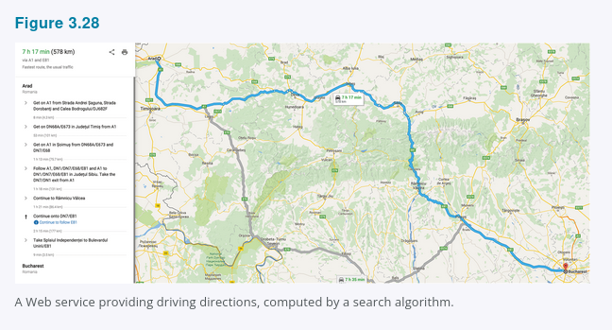

We could generate a perfect heuristic by precomputing and storing the cost of the optimal path between every pair of vertices. That would take O(|V|^2) space, and O(|E|^3) time, practical for graphs with 10 thousand vertices, but not 10 million.
A better approach is to choose a few perhaps 10 or 20 landmark points from the vertices. Then for each landmark L and for each other vertex v in the graph, we compute and store C^(v, L), the exact cost of the optimal path from v to L. We also need C^(L, v); on an undirected graph this is the same as C^(v, L); on a directed graph e.g., with one-way streets, we need to compute this separately. Given the stored C^ tables, we can easily create an efficient although inadmissible heuristic: the minimum, over all landmarks, of the cost of getting from the current node to the landmark, and then to the goal:
hL(n) = min over L in Landmarks C*(n, L) + C*(L, goal)
If the optimal path happens to go through a landmark, this heuristic will be exact; if not it is inadmissible, it overestimates the cost to the goal. In an A* search, if you have exact heuristics, then once you reach a node that is on an optimal path, every node you expand from then on will be on an optimal path. Think of the contour lines as following along this optimal path. The search will trace along the optimal path, on each iteration adding an action with cost c to get to a result state whose h-value will be c less, meaning that the total f = g + h score will remain constant at C^* all along the path.
Some route-finding algorithms save even more time by adding shortcuts, artificial edges in the graph that define an optimal multi-action path. For example, if there were shortcuts predefined between all the 100 biggest cities in the U.S., and we were trying to navigate from the Berkeley campus in California to NYU in New York, we could take the shortcut between Sacramento and Manhattan and cover 90% of the path in one action.
hL(n) is efficient but not admissible. But with a bit more care, we can come up with a heuristic that is both efficient and admissible:
hDH(n) = max over L in Landmarks |C*(n, L) - C*(goal, L)|
This is called a differential heuristic because of the subtraction. Think of this with a landmark that is somewhere out beyond the goal. If the goal happens to be on the optimal path from n to the landmark, then this is saying “consider the entire path from n to L, then subtract off the last part of that path, from goal to L, giving us the exact cost of the path from n to goal.” To the extent that the goal is a bit off of the optimal path to the landmark, the heuristic will be inexact, but still admissible. Landmarks that are not out beyond the goal will not be useful; a landmark that is exactly halfway between n and goal will give hDH = 0, which is not helpful.
There are several ways to pick landmark points. Selecting points at random is fast, but we get better results if we take care to spread the landmarks out so they are not too close to each other. A greedy approach is to pick a first landmark at random, then find the point that is furthest from that, and add it to the set of landmarks, and continue, at each iteration adding the point that maximizes the distance to the nearest landmark. If you have logs of past search requests by your users, then you can pick landmarks that are frequently requested in searches. For the differential heuristic it is good if the landmarks are spread around the perimeter of the graph. Thus, a good technique is to find the centroid of the graph, arrange k pie-shaped wedges around the centroid, and in each wedge select the vertex that is farthest from the center.
Landmarks work especially well in route-finding problems because of the way roads are laid out in the world: a lot of traffic actually wants to travel between landmarks, so civil engineers build the widest and fastest roads along these routes; landmark search makes it easier to recover these routes.

3.6.5 Learning to search better
We have presented several fixed search strategies, breadth-first, A*, and so on, that have been carefully designed and programmed by computer scientists. Could an agent learn how to search better? The answer is yes, and the method rests on an important concept called the metalevel state space. Each state in a metalevel state space captures the internal computational state of a program that is searching in an ordinary state space such as the map of Romania. To keep the two concepts separate, we call the map of Romania an object-level state space. For example, the internal state of the A* algorithm consists of the current search tree. Each action in the metalevel state space is a computation step that alters the internal state; for example, each computation step in A* expands a leaf node and adds its successors to the tree. Thus, Figure 3.18, which shows a sequence of larger and larger search trees, can be seen as depicting a path in the metalevel state space where each state on the path is an object-level search tree.
Now, the path in Figure 3.18 has five steps, including one step, the expansion of Fagaras, that is not especially helpful. For harder problems, there will be many such missteps, and a metalevel learning algorithm can learn from these experiences to avoid exploring unpromising subtrees. The techniques used for this kind of learning are described in Chapter 22. The goal of learning is to minimize the total cost of problem solving, trading off computational expense and path cost.

3.6.6 Learning heuristics from experience
We have seen that one way to invent a heuristic is to devise a relaxed problem for which an optimal solution can be found easily. An alternative is to learn from experience. “Experience” here means solving lots of 8-puzzles, for instance. Each optimal solution to an 8-puzzle problem provides an example goal, path pair. From these examples, a learning algorithm can be used to construct a function h that can with luck approximate the true path cost for other states that arise during search. Most of these approaches learn an imperfect approximation to the heuristic function, and thus risk inadmissibility. This leads to an inevitable tradeoff between learning time, search run time, and solution cost. Techniques for machine learning are demonstrated in Chapter 19. The reinforcement learning methods described in Chapter 22 are also applicable to search.
Some machine learning techniques work better when supplied with features of a state that are relevant to predicting the state’s heuristic value, rather than with just the raw state description. For example, the feature “number of misplaced tiles” might be helpful in predicting the actual distance of an 8-puzzle state from the goal. Let’s call this feature x1(n). We could take 100 randomly generated 8-puzzle configurations and gather statistics on their actual solution costs. We might find that when x1(n) is 5, the average solution cost is around 14, and so on. Of course, we can use multiple features. A second feature x2(n) might be “number of pairs of adjacent tiles that are not adjacent in the goal state.” How should x1(n) and x2(n) be combined to predict h(n)? A common approach is to use a linear combination:
h(n) = c1x1(n) + c2x2(n).
The constants c1 and c2 are adjusted to give the best fit to the actual data across the randomly generated configurations. One expects both c1 and c2 to be positive because misplaced tiles and incorrect adjacent pairs make the problem harder to solve. Notice that this heuristic satisfies the condition h(n) = 0 for goal states, but it is not necessarily admissible or consistent.

Summary
This chapter has introduced search algorithms that an agent can use to select action sequences in a wide variety of environments, as long as they are episodic, single-agent, fully observable, deterministic, static, discrete, and completely known. There are tradeoffs to be made between the amount of time the search takes, the amount of memory available, and the quality of the solution. We can be more efficient if we have domain-dependent knowledge in the form of a heuristic function that estimates how far a given state is from the goal, or if we precompute partial solutions involving patterns or landmarks.
- Before an agent can start searching, a well-defined problem must be formulated.
- A problem consists of five parts: the initial state, a set of actions, a transition model describing the results of those actions, a set of goal states, and an action cost function.
- The environment of the problem is represented by a state space graph. A path through the state space, a sequence of actions from the initial state to a goal state, is a solution.
- Search algorithms generally treat states and actions as atomic, without any internal structure, although we introduced features of states when it came time to do learning.
- Search algorithms are judged on the basis of completeness, cost optimality, time complexity, and space complexity.
- Uninformed search methods have access only to the problem definition. Algorithms build a search tree in an attempt to find a solution. Algorithms differ based on which node they expand first:
  - Best-first search selects nodes for expansion using an evaluation function.
  - Breadth-first search expands the shallowest nodes first; it is complete, optimal for unit action costs, but has exponential space complexity.
  - Uniform-cost search expands the node with lowest path cost, g(n), and is optimal for general action costs.
  - Depth-first search expands the deepest unexpanded node first. It is neither complete nor optimal, but has linear space complexity. Depth-limited search adds a depth bound.
  - Iterative deepening search calls depth-first search with increasing depth limits until a goal is found. It is complete when full cycle checking is done, optimal for unit action costs, has time complexity comparable to breadth-first search, and has linear space complexity.
  - Bidirectional search expands two frontiers, one around the initial state and one around the goal, stopping when the two frontiers meet.
- Informed search methods have access to a heuristic function h(n) that estimates the cost of a solution from n. They may have access to additional information such as pattern databases with solution costs.
  - Greedy best-first search expands nodes with minimal h(n). It is not optimal but is often efficient.
  - A search* expands nodes with minimal f(n) = g(n) + h(n). A* is complete and optimal, provided that h(n) is admissible. The space complexity of A* is still an issue for many problems.
  - Bidirectional A search* is sometimes more efficient than A* itself.
  - IDA* iterative deepening A* search is an iterative deepening version of A*, and thus addresses the space complexity issue.
  - RBFS recursive best-first search and SMA* simplified memory-bounded A* are robust, optimal search algorithms that use limited amounts of memory; given enough time, they can solve problems for which A* runs out of memory.
  - Beam search puts a limit on the size of the frontier; that makes it incomplete and suboptimal, but it often finds reasonably good solutions and runs faster than complete searches.
  - Weighted A* search focuses the search towards a goal, expanding fewer nodes, but sacrificing optimality.
- The performance of heuristic search algorithms depends on the quality of the heuristic function. One can sometimes construct good heuristics by relaxing the problem definition, by storing precomputed solution costs for subproblems in a pattern database, by defining landmarks, or by learning from experience with the problem class.

Bibliographical and Historical Notes
The topic of state-space search originated in the early years of AI. Newell and Simon’s work on the Logic Theorist 1957 and GPS 1961 led to the establishment of search algorithms as the primary tool for 1960s AI researchers and to the establishment of problem solving as the canonical AI task. Work in operations research by Richard Bellman 1957 showed the importance of additive path costs in simplifying optimization algorithms. The text by Nils Nilsson 1971 established the area on a solid theoretical footing.
The 8-puzzle is a smaller cousin of the 15-puzzle, whose history is recounted at length by Slocum and Sonneveld 2006. In 1880, the 15-puzzle attracted broad attention from the public and mathematicians Johnson and Story, 1879; Tait, 1880. The editors of the American Journal of Mathematics stated, “The ‘15’ puzzle for the last few weeks has been prominently before the American public, and may safely be said to have engaged the attention of nine out of ten persons of both sexes and all ages and conditions of the community,” while the Weekly News-Democrat of Emporia, Kansas wrote on March 12, 1880 that “It has become literally an epidemic all over the country.”
The famous American game designer Sam Loyd falsely claimed to have invented the 15 puzzle Loyd, 1959; actually it was invented by Noyes Chapman, a postmaster in Canastota, New York, in the mid-1870s although a generic patent covering sliding blocks was granted to Ernest Kinsey in 1878. Ratner and Warmuth 1986 showed that the general n x n version of the 15-puzzle belongs to the class of NP-complete problems.
Rubik’s Cube was of course invented in 1974 by Ernő Rubik, who also discovered an algorithm for finding good, but not optimal solutions. Korf 1997 found optimal solutions for some random problem instances using pattern databases and IDA* search. Rokicki et al. 2014 proved that any instance can be solved in 26 moves if you consider a 180° twist to be two moves; 20 if it counts as one. The proof consumed 35 CPU years of computation; it does not lead immediately to an efficient algorithm. Agostinelli et al. 2019 used reinforcement learning, deep learning networks, and Monte Carlo tree search to learn a much more efficient solver for Rubik’s cube. It is not guaranteed to find a cost-optimal solution, but does so about 60% of the time, and typical solutions times are less than a second.
Each of the real-world search problems listed in the chapter has been the subject of a good deal of research effort. Methods for selecting optimal airline flights remain proprietary for the most part, but Carl de Marcken has shown by a reduction to Diophantine decision problems that airline ticket pricing and restrictions have become so convoluted that the problem of selecting an optimal flight is formally undecidable Robinson, 2002. The traveling salesperson problem TSP is a standard combinatorial problem in theoretical computer science Lawler et al., 1992. Karp 1972 proved the TSP decision problem to be NP-hard, but effective heuristic approximation methods were developed Lin and Kernighan, 1973. Arora 1998 devised a fully polynomial approximation scheme for Euclidean TSPs. VLSI layout methods are surveyed by LaPaugh 2010, and many layout optimization papers appear in VLSI journals. Robotic navigation is discussed in Chapter 26. Automatic assembly sequencing was first demonstrated by Freddy Michie, 1972; a comprehensive review is given by Bahubalendruni and Biswal, 2016.
Uninformed search algorithms are a central topic of computer science Cormen et al., 2009 and operations research Dreyfus, 1969. Breadth-first search was formulated for solving mazes by Moore 1959. The method of dynamic programming Bellman, 1957; Bellman and Dreyfus, 1962, which systematically records solutions for all subproblems of increasing lengths, can be seen as a form of breadth-first search.
Dijkstra’s algorithm in the form it is usually presented in Dijkstra, 1959 is applicable to explicit finite graphs. Nilsson 1971 introduced a version of Dijkstra’s algorithm that he called uniform-cost search because the algorithm “spreads out along contours of equal path cost” that allows for implicitly defined, infinite graphs. Nilsson’s work also introduced the idea of closed and open lists, and the term “graph search.” The name Best-First-Search was introduced in the Handbook of AI Barr and Feigenbaum, 1981. The Floyd-Warshall Floyd, 1962 and Bellman-Ford Bellman, 1958; Ford, 1956 algorithms allow negative step costs as long as there are no negative cycles.
A version of iterative deepening designed to make efficient use of the chess clock was first used by Slate and Atkin 1977 in the Chess 4.5 game-playing program. Martelli’s algorithm B 1977 also includes an iterative deepening aspect. The iterative deepening technique was introduced by Bertram Raphael 1976 and came to the fore in work by Korf 1985a.
The use of heuristic information in problem solving appears in an early paper by Simon and Newell 1958, but the phrase “heuristic search” and the use of heuristic functions that estimate the distance to the goal came somewhat later Newell and Ernst, 1965; Lin, 1965. Doran and Michie 1966 conducted extensive experimental studies of heuristic search. Although they analyzed path length and “penetrance” the ratio of path length to the total number of nodes examined so far, they appear to have ignored the information provided by the path cost g(n). The A* algorithm, incorporating the current path cost into heuristic search, was developed by Hart, Nilsson, and Raphael 1968. Dechter and Pearl 1985 studied the conditions under which A* is optimally efficient in number of nodes expanded.
The original A* paper Hart et al., 1968 introduced the consistency condition on heuristic functions. The monotone condition was introduced by Pohl 1977 as a simpler replacement, but Pearl 1984 showed that the two were equivalent.
Pohl 1977 pioneered the study of the relationship between the error in heuristic functions and the time complexity of A*. Basic results were obtained for tree-like search with unit action costs and a single goal state Pohl, 1977; Gaschnig, 1979; Huyn et al., 1980; Pearl, 1984 and with multiple goal states Dinh et al., 2007. Korf and Reid 1998 showed how to predict the exact number of nodes expanded not just an asymptotic approximation on a variety of actual problem domains. The “effective branching factor” was proposed by Nilsson 1971 as an empirical measure of efficiency. For graph search, Helmert and Röger 2008 noted that several well-known problems contained exponentially many nodes on optimal-cost solution paths, implying exponential time complexity for A*.
There are many variations on the A* algorithm. Pohl 1970 introduced weighted A* search, and later a dynamic version 1973, where the weight changes over the depth of the tree. Ebendt and Drechsler 2009 synthesize the results and examine some applications. Hatem and Ruml 2014 show a simplified and improved version of weighted A* that is easier to implement. Wilt and Ruml 2014 introduce speedy search as an alternative to greedy search that focuses on minimizing search time, and Wilt and Ruml 2016 show that the best heuristics for satisficing search are different from the ones for optimal search. Burns et al. 2012 give some implementation tricks for writing fast search code, and Felner 2018 considers how the implementation changes when using an early goal test.
Pohl 1971 introduced bidirectional search. Holte et al. 2016 describe the version of bidirectional search that is guaranteed to meet in the middle, making it more widely applicable. Eckerle et al. 2017 describe the set of surely expanded pairs of nodes, and show that no bidirectional search can be optimally efficient. The NBS algorithm Chen et al., 2017 makes explicit use of a queue of pairs of nodes.
A combination of bidirectional A* and known landmarks was used to efficiently find driving routes for Microsoft’s online map service Goldberg et al., 2006. After caching a set of paths between landmarks, the algorithm can find an optimal-cost path between any pair of points in a 24-million-point graph of the United States, searching less than 0.1% of the graph. Korf 1987 shows how to use subgoals, macro-operators, and abstraction to achieve remarkable speedups over previous techniques. Delling et al. 2009 describe how to use bidirectional search, landmarks, hierarchical structure, and other tricks to find driving routes. Anderson et al. 2008 describe a related technique, called coarse-to-fine search, which can be thought of as defining landmarks at various hierarchical levels of abstraction. Korf 1987 describes conditions under which coarse-to-fine search provides an exponential speedup. Knoblock 1991 provides experimental results and analysis to quantify the advantages of hierarchical search.
A* and other state-space search algorithms are closely related to the branch-and-bound techniques that are widely used in operations research Lawler and Wood, 1966; Rayward-Smith et al., 1996. Kumar and Kanal 1988 attempt a “grand unification” of heuristic search, dynamic programming, and branch-and-bound techniques under the name of CDP, the “composite decision process.”
Because most computers in the 1960s had only a few thousand words of main memory, memory-bounded heuristic search was an early research topic. The Graph Traverser Doran and Michie, 1966, one of the earliest search programs, commits to an action after searching best-first up to the memory limit. IDA* Korf, 1985b was the first widely used length-optimal, memory-bounded heuristic search algorithm, and a large number of variants have been developed. An analysis of the efficiency of IDA* and of its difficulties with real-valued heuristics appears in Patrick et al. 1992.
The original version of RBFS Korf, 1993 is actually somewhat more complicated than the algorithm shown in Figure 3.22, which is actually closer to an independently developed algorithm called iterative expansion or IE Russell, 1992. RBFS uses a lower bound as well as the upper bound; the two algorithms behave identically with admissible heuristics, but RBFS expands nodes in best-first order even with an inadmissible heuristic. The idea of keeping track of the best alternative path appeared earlier in Bratko’s 2009 elegant Prolog implementation of A* and in the DTA* algorithm Russell and Wefald, 1991. The latter work also discusses metalevel state spaces and metalevel learning.
The MA* algorithm appeared in Chakrabarti et al. 1989. SMA*, or Simplified MA*, emerged from an attempt to implement MA* Russell, 1992. Kaindl and Khorsand 1994 applied SMA* to produce a bidirectional search algorithm that was substantially faster than previous algorithms. Korf and Zhang 2000 describe a divide-and-conquer approach, and Zhou and Hansen 2002 introduce memory-bounded A* graph search and a strategy for switching to breadth-first search to increase memory-efficiency Zhou and Hansen, 2006.
The idea that admissible heuristics can be derived by problem relaxation appears in the seminal paper by Held and Karp 1970, who used the minimum-spanning-tree heuristic to solve the TSP. See Exercise 3.MSTR. The automation of the relaxation process was implemented successfully by Prieditis 1993. There is a growing literature on the application of machine learning to discover heuristic functions Samadi et al., 2008; Arfaee et al., 2010; Thayer et al., 2011; Lelis et al., 2012.
The use of pattern databases to derive admissible heuristics is due to Gasser 1995 and Culberson and Schaeffer 1996, 1998; disjoint pattern databases are described by Korf and Felner 2002; a similar method using symbolic patterns is due to Edelkamp 2009. Felner et al. 2007 show how to compress pattern databases to save space. The probabilistic interpretation of heuristics was investigated by Pearl 1984 and Hansson and Mayer 1989.
Pearl’s 1984 Heuristics and Edelkamp and Schrödl’s 2012 Heuristic Search are influential textbooks on search. Papers about new search algorithms appear at the International Symposium on Combinatorial Search SoCS and the International Conference on Automated Planning and Scheduling ICAPS, as well as in general AI conferences such as AAAI and IJCAI, and journals such as Artificial Intelligence and Journal of the ACM.

